**1. Linux booting process**

**Question: How does the service run on the first booting?**

*Answer:* When a Linux system boots for the first time, it goes through a series of well-defined stages. These steps help the system initialize hardware, load the operating system, and start necessary services.

1. **BIOS (loads and executes the MBR boot loader)- Integrity Check**

* Run when the computer is powered on
* Performs hardware checks
* After then, searches for and loads the bootloader from a bootable device (HDD, SSD, USB, …)

1. **MBR (Master Boot Record - response for loading and executing the GRUB boot loader) - Execute GRUB**

* Located the first sector of the boot disk (/dev/sda,...)
* Contains the information to load and run the bootloader, typically GRUB

1. **GRUB (GRand Unified Bootloader is the typical boot loader for most modern Linux systems) - Executes Kernel**

* Display a boot menu for selecting the Linux Kernel (if multiple are available)
* Load the selected Kernel and initial RAM disk into the memory
* Passes control to the kernel

1. **Kernel (The core of the operating system. It has complete control over everything in system) - Executes init.d**

* initializes hardware and mounts the root file system
* Loads and starts the first user space program: /sbin/init (PID 1)
* Uses *initrd(temporary root used before real root file system is ready)* temporarily before the actual root file system is mounted

1. **Init - Initiate Runlevel**

* The init system manages startup services and targets (modern systems use *systemd - modern init system, replaces older SysVinit and Upstart*)
* Determines the system’s runlevel/target:
* Run Level 0: half - poweroff.target (runlevel0.target -> poweroff.target)
* Run Level 1: single user mode - rescue.target (runlevel1.target -> rescue.target)
* Run Level 3: multiuser, without NFS - multil-user.target (runlevel3.target -> multil-user.target)
* Run Level 5: X11 - graphical.target (runlevel5.target -> graphical.target)
* Run Level 6: reboot - reboot.target (runlevel6.target -> reboot.target)
* Emergency -> emergency.target
* Starts essential system services accordingly

1. **Runlevels - Execute Runlevel**

* Based on the selected runlevel/target, system services are started (SSH, cron, networking, …)
* On traditional systems, startup scripts are located on /etc/rc*.d/ with:
* S: Start
* K: Kill
* These directories vary depending on runlevel (0 -> 6)

6 stages of Linux Boot process (Startup queue):

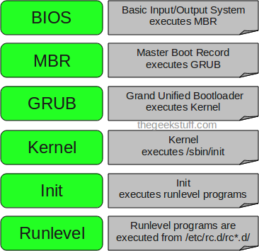

ref: <https://www.thegeekstuff.com/2011/02/linux-boot-process/>

**2. The role of GRUB (MBR)**

**Question 1: What is MBR?**

*Answer:*

* The Master Boot Record (MBR) is the first sector of the hard drive, containing important information for booting the operating system
* It tells the computer “where the operating system is” and “how to load into RAM” to start the system
* Maximum size 512 bytes
* Structure include: master boot routine (446 bytes), disk partition table (64 bytes), identification code (2 bytes)
* When the computer turn on, the BIOS check the hardware and looks for a boot device. The BIOS reads the MBR at address 0000:7C00H and checks for the signature 55AAH. If valid, the BIOS hands over control to the MBR to continue the OS boot process

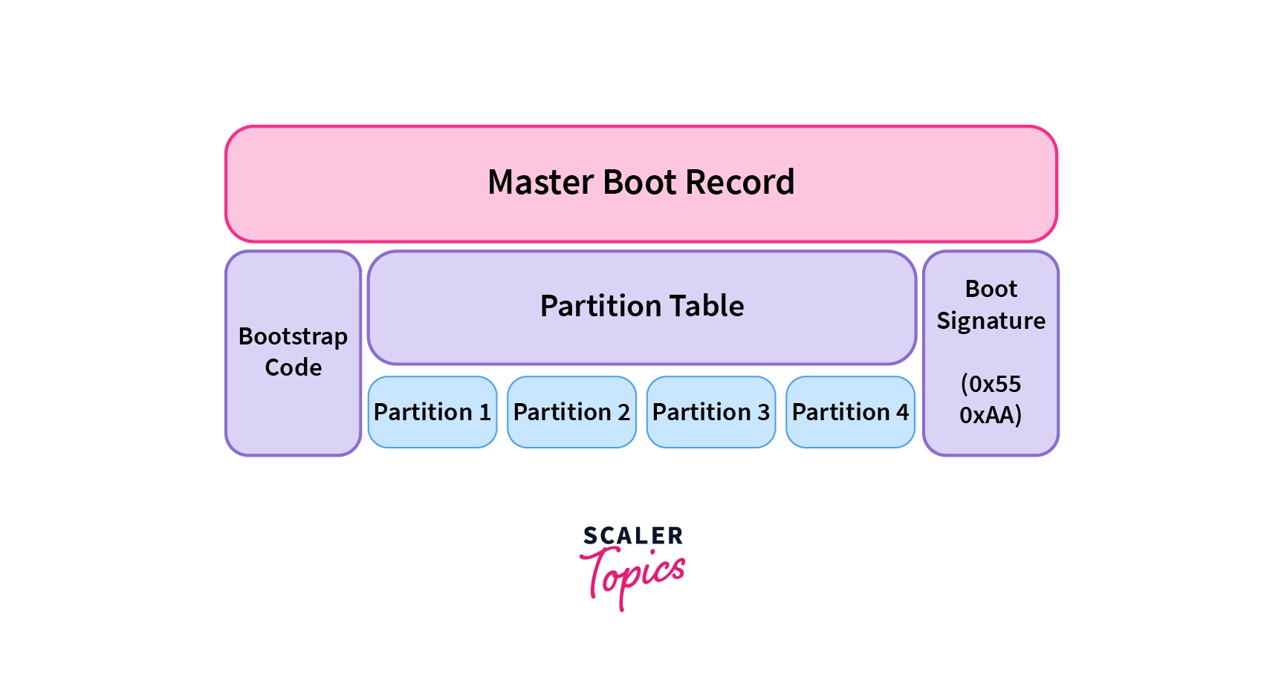

ref: [https://www.scaler.com/topics/operating-system/master-boot-record/a](https://www.scaler.com/topics/operating-system/master-boot-record/)

**Question 2: What is GRUB?**

*Answer:*

* The GRUB (GNU GRand Unified Bootloader) is a bootloader and boot manager used in Linux and Unix-like operating systems
* It starts immediately after the BIOS completes hardware checks, and is loaded from the MBR
* There are 2 versions:
* GRUB Legacy (GRUB 1): old, outdated but still exists on some older systems
* GRUB 2: modern, supports many architectures (ARM), RAID systems, LVM, modern file systems like ReiserFS
* GRUB handle both roles:
* bootloader: load the operating system kernel into RAM, initialize the hardware
* boot manager: interface for user to select operating system to boot
* After selecting OS or special mode (safe mode, ...), GRUB loads the corresponding kernel based on the parameters:
* BOOT_IMAGE: A kernel location
* initrd: loads temporary filesystem to RAM
* root: identifies root partition
* quiet, ro, splash: controls display and file system access during boot
* GRUB boots in 2 or 3 stages:
* stage 1: Load first from MBR, very small, just to start the next stage
* stage 1.5 (optional): Support loading Stage 2 from complex file system
* stage 2: Display menu, load kernel, initialize kernel and user space

**Question 3: How to reinstall the GRUB**

*Answer (practice on CentOS9):*Depending on the system type:

**For BIOS:**

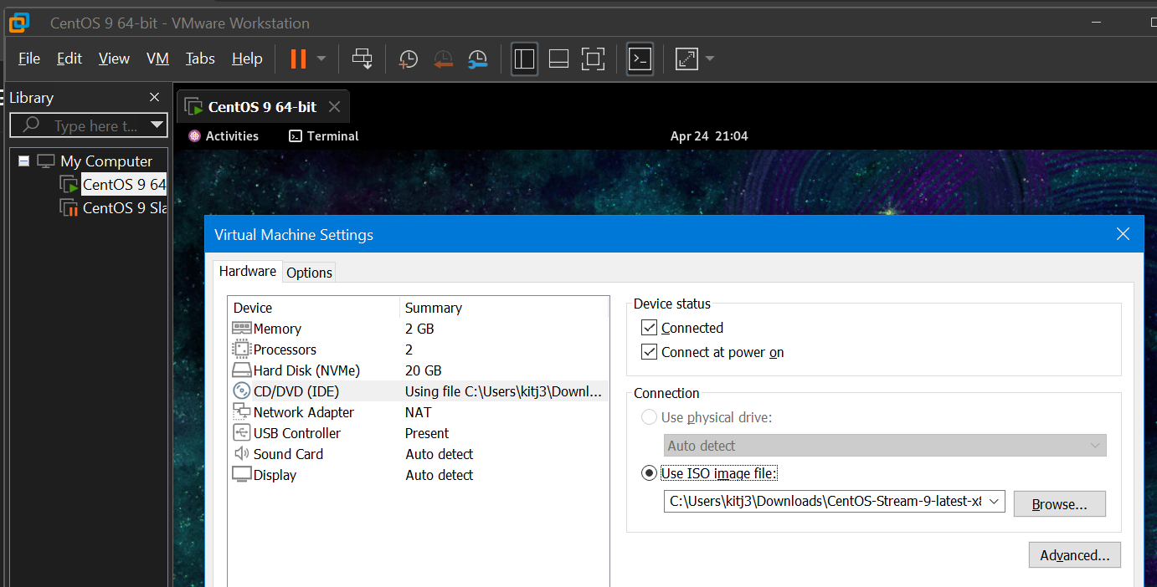

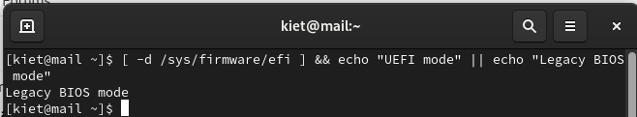

* Identify the root partition: *fdisk -l*

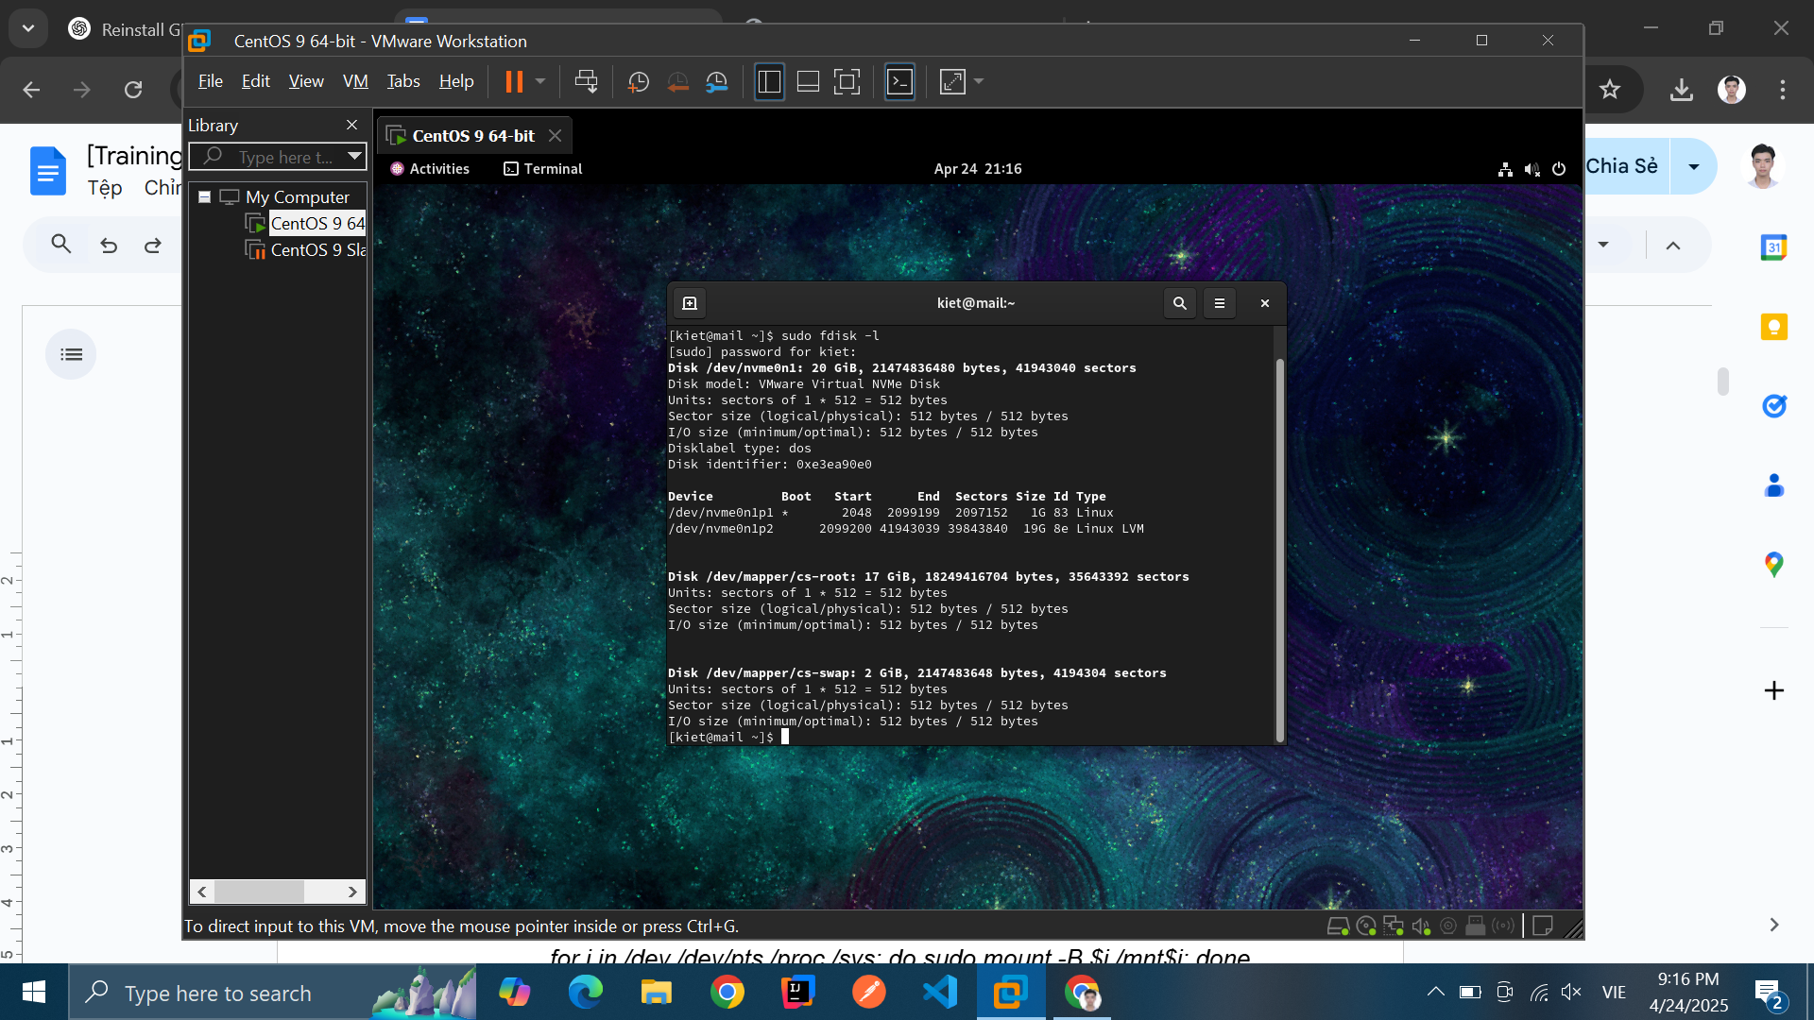

* Mount the root partition to */dev/mapper/cs-root:*

*sudo mount /dev/mapper/cs-root /mnt*

* Mount the boot partition to /dev/nvme0n1p1 /mnt/boot:

*sudo mount /dev/nvme0n1p1 /mnt/boot*

**

* mount the necessary system folders (mount the necessary directories to be able to use chroot into the system)

*for i in /dev /dev/pts /proc /sys; do sudo mount --bind $i /mnt$i; done*

* in a chroot environment, **/etc/resolv.conf** from the root system (in /mnt) already exists and is a copy of /etc/resolv.conf on the system. Recreate the **resolv.con**f file - make sure the system can connect to the network when chrooted:

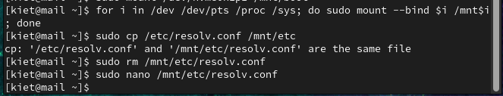

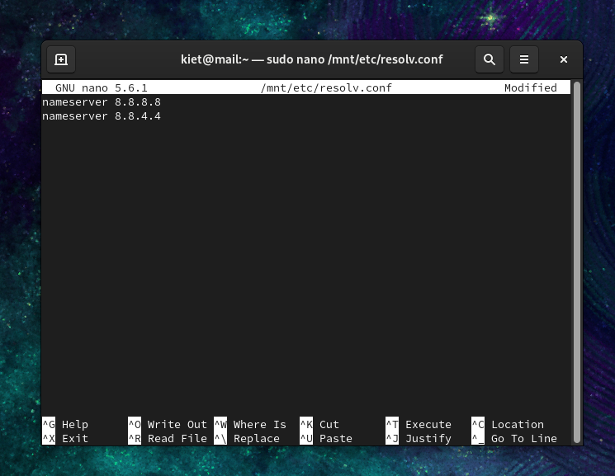

* chroot into CentOS system

sudo chroot /mnt

*see **root@mail** instead of **kiet@mail**

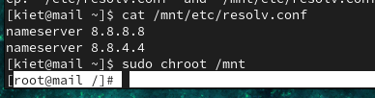

* reinstall GRUB for BIOS system

grub2-install /dev/nvme0n1

* reconfigure GRUB so that the system can correctly recognize the operating systems

grub2-mkconfig -o /boot/grub2/grub.cfg

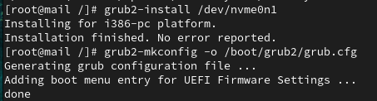

* exit chroot and unmount partitions

exit

sudo umount -R /mnt

* reboot

**For UEFI:**

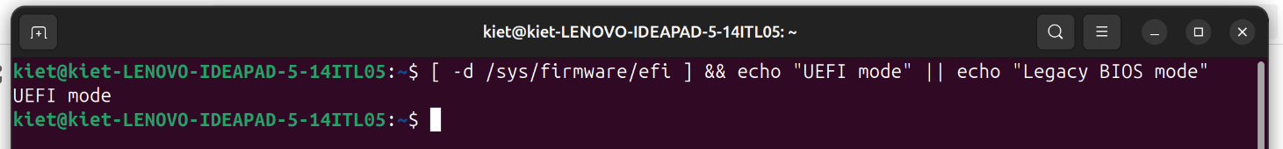

* Identify the root partition: *fdisk -l*

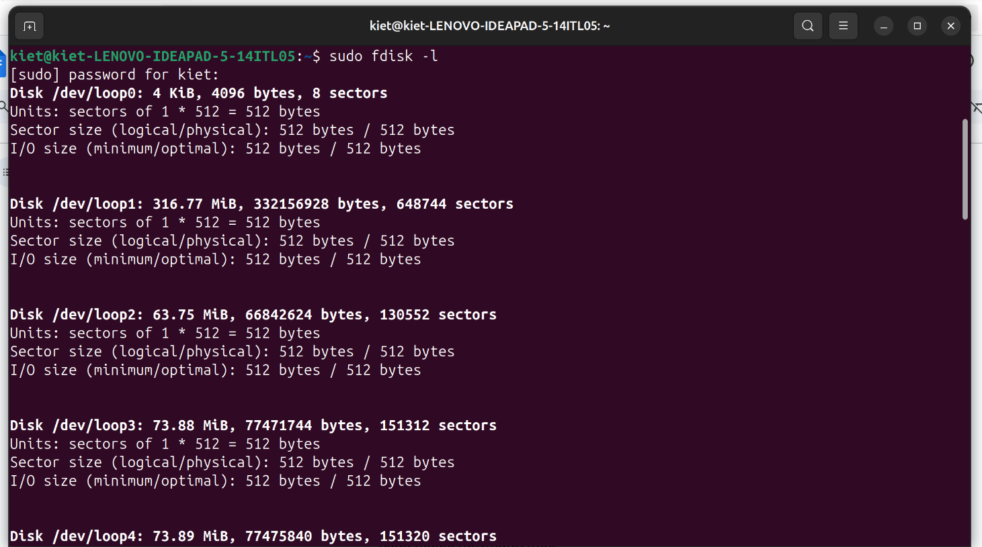

* EFI system partition: **/dev/nvme0n1p1**

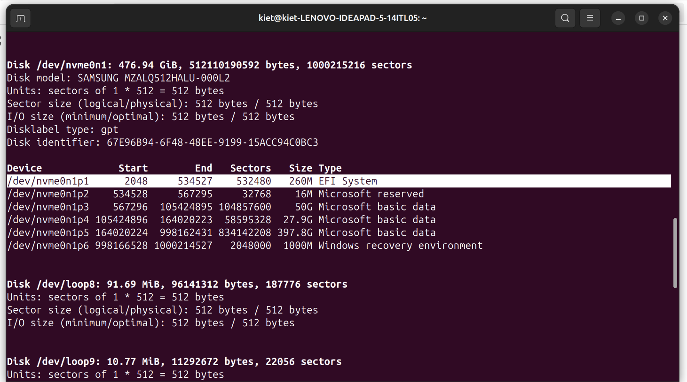

* Ubuntu root:

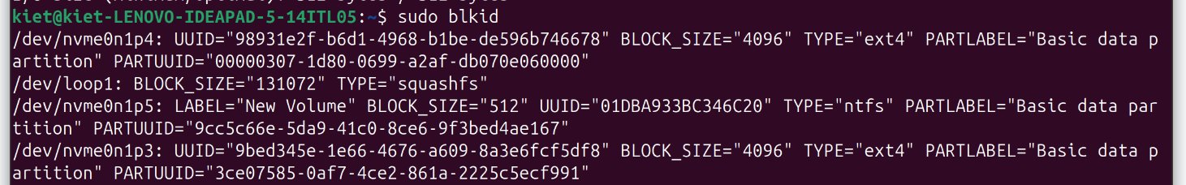

***!!!*** */dev/nvme0n1p4 and /dev/nvme0n1p3 both have type "ext4". Need to check further:*

* check /dev/nvme0n1p3:

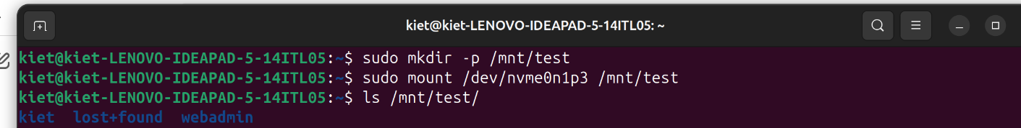

* check */dev/nvme0n1p4:*

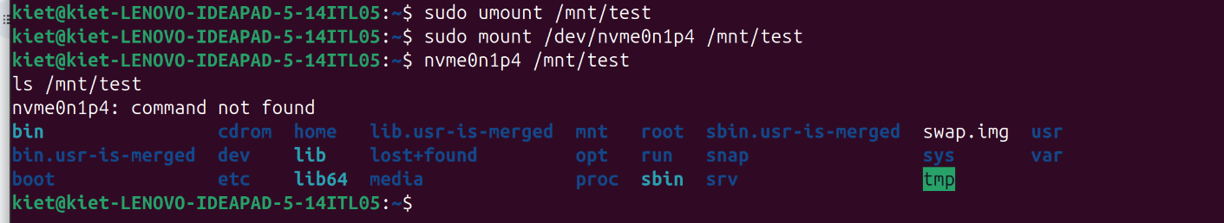

*=> Ubuntu root (/) is: /dev/nvme0n1p4*

* mount root partition (Ubuntu): /dev/nvme0n1p4

sudo mount /dev/nvme0n1p4 /mnt

* mount EFI partition: /dev/nvme0n1p1

*sudo mount /dev/nvme0n1p1 /mnt/boot/efi*

* use the chroot command to change the root directory, allowing access and modification to the Ubuntu system

sudo mount --bind /dev /mnt/dev

sudo mount --bind /proc /mnt/proc

sudo mount --bind /sys /mnt/sys

sudo mount --bind /run /mnt/run

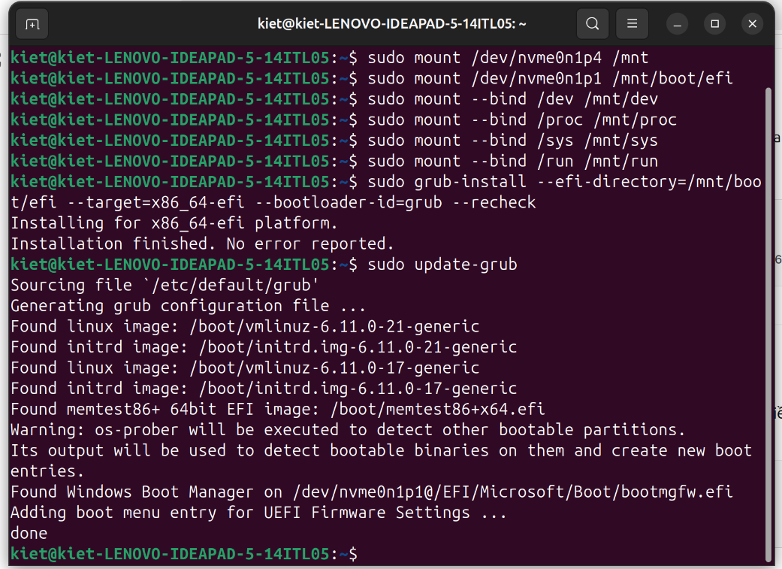

* into Ubuntu environment via chroot

sudo chroot /mnt



* reinstall GRUB to EFI drive

grub-install --efi-directory=/boot/efi --target=x86_64-efi --bootloader-id=grub --recheck

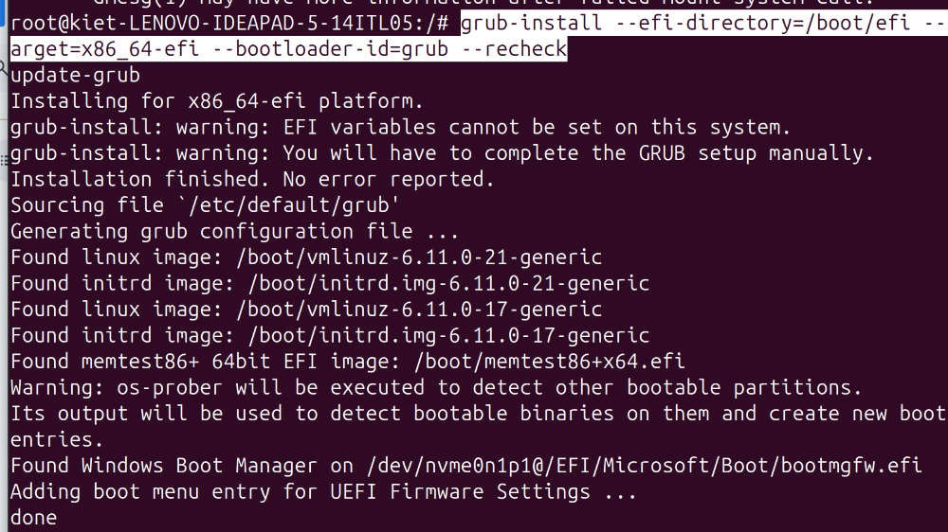

* update grub

sudo update-grub

* exit chroot environment: exit
* sudo reboot

**3. Research how to set /etc/fstab, way tofastboot**

**Question 1: Meaning of fstab by item**

*Answer:* fstab (File System Table) is an important configuration file that contains information about file systems and storage devices that need to be mounted automatically when the system boots. It manages and controls the file systems and storage devices mounted on the system. The Fstab file is located in the “etc” directory. The specific path is “/etc/fstab”

* Device: usually the given name or UUID of the mounted device (sda1/sda2/etc)
* Mount Point: designates the directory where the device is/will be mounted
* File System Type: nothing trick here, shows the type of filesystem in use
* Options: lists any active mount options. If using multiple options they must be separated by commas
* Backup Operation: (the first digit) this is a binary system where 1 = dump utility backup of a partition. 0 = no backup. This is an outdated backup method and should NOT be used
* File System Check Order: (second digit) Here we can see three possible outcomes. 0 means that fsck will not check the filesystem. Numbers higher than this represent the check order. The root filesystem should be set to 1 and other partitions set to 2

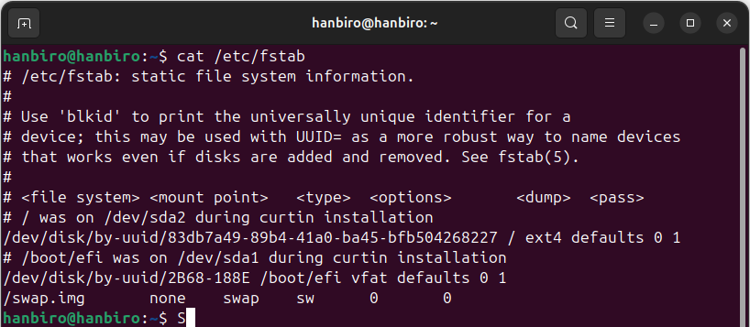

**Question 2: Reason of add a discard option for SSD?**

The *discard* option enables TRIM, which allows the the operating system to inform the SSD controller about unused blocks. This help:

* Reclaim free space efficiently
* Reduce write amplification
* Improve performance and extend SSD lifespan

**Question 3: Reason of add noexec, nosuid options for tmp partition?**

* Without noexec: Attackers can place and run malicious binaries in */tmp.*

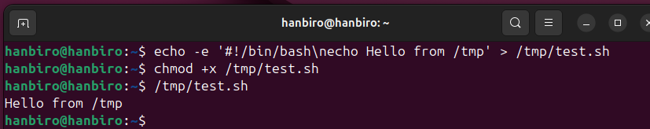

* With noexec: Prevents execution of binaries in */tmp*

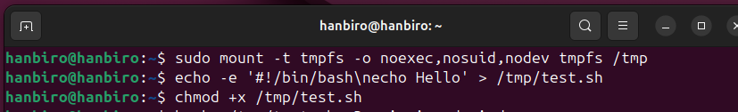

**

* Without nosuid: Binaries with *setuid* can be used to escalate privileges

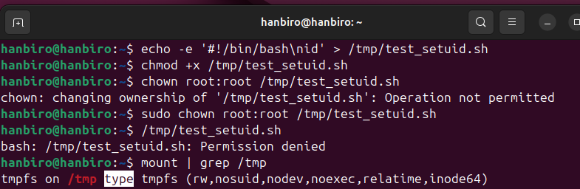

* *With* **nosuid**: Blocks *SUID/SGID* execution, reducing privilege escalation risk

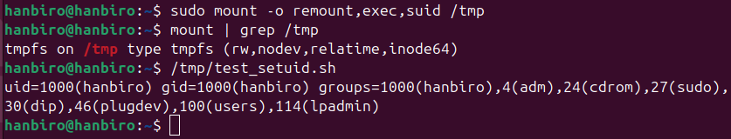

**4. Method of Single mode access**

**- CentOs 6**

* Reboot the system
* At the GRUB menu, highlight the desired kernel and press “e” to edit
* Find the line starting with “kernel” and go to the end of line
* Add ‘single’ (enter runlevel 1) or ‘*init=/bin/bash’* (drop directly into a shell without running init) at the end of that line:

*kernel /vmlinuz-2.6.x root=/dev/sda1 ro …*

* Press “b” to boot (or Ctrl+X in some versions)
* The system will boot into Single User Mode with root access (no password required)

**- CentOs 7**

***METHOD 1: Using rw init=/sysroot/bin/bash in GRUB***

* Reboot the system
* At the GRUB menu, highlight the CentOS boot entry and press “e”
* Find the line starting with “linux16” or “linuxefi”
* Replace “ro” with:

*rw init=/sysroot/bin/bash*

* Press Ctrl+X to boot
* At Prompt, remount root as read-write:

*chroot /sysroot*

* *Reboot*

***METHOD 2: Using rd.break in GRUB***

* Interrupt GRUB with e, edit the linux16 line, add at the end:

*rd.break*

* Press Ctrl+X to boot
* */sysroot* mounted as read-only
* Remount */sysroot* as read-write:

mount -o remount,rw /sysroot

* Chroot into the system:

*chroot /sysroot*

* exit -> reboot

***METHOD 3: Using init=/bin/bash in GRUB***

* Interrupt GRUB menu, press “e”, and at the end of linux16 line, append:

*init=/bin/bash*

* Press Ctrl+X to boot
* Root file system is mounted directly as “/”, but read-only
* Remount it as read-write:

*mount -o remount,rw /*

**5. Logrotate**

**Question: syslog.conf setting (meaning by item)**

* file location is /etc/rsyslog.conf

on **Ubuntu 24.04.2 LTS**

Answer:

* facility: specify the the souce or category of the log massage
* auth, authpriv – authentication and security logs
* cron – scheduled tasks (crontab)
* daemon – system services
* kern – kernel messages
* mail – mail system
* user – user-level applications
* local0 to local7 – custom use by applications
* priority: define the severity level of the log massage
* debug – debugging messages
* info – general information
* notice – important but normal events
* warning – potential issues
* err – error conditions
* crit – critical conditions
* alert – requires immediate attention
* emerg – system is unusable
* destination: indicate where to send or store the log, can be:
* local file: /var/log/secure, …
* device: /dev/console, …
* remote host: @remost-hostname, …

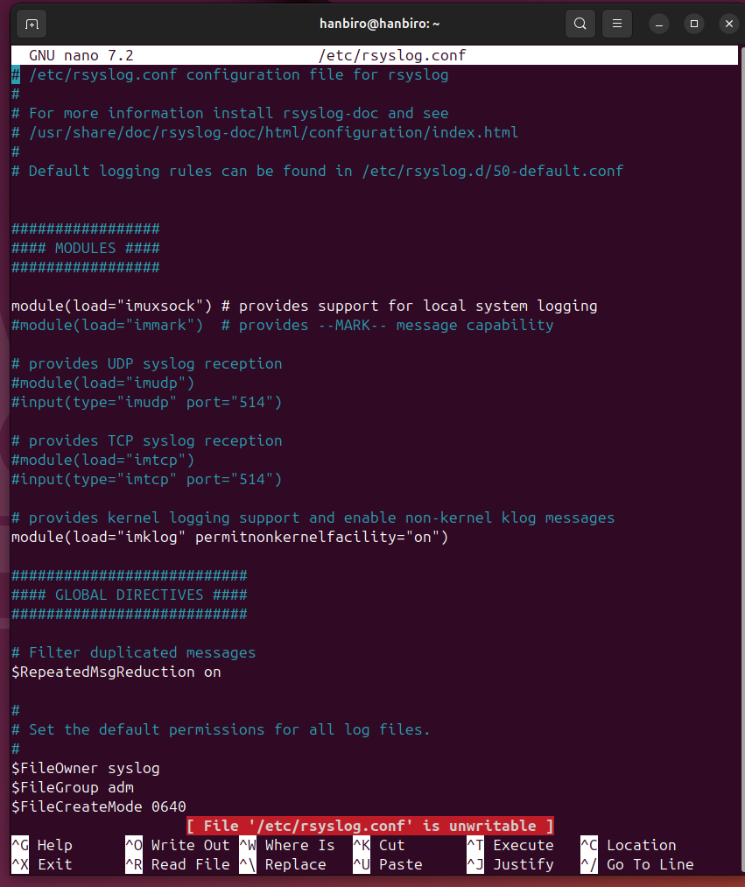

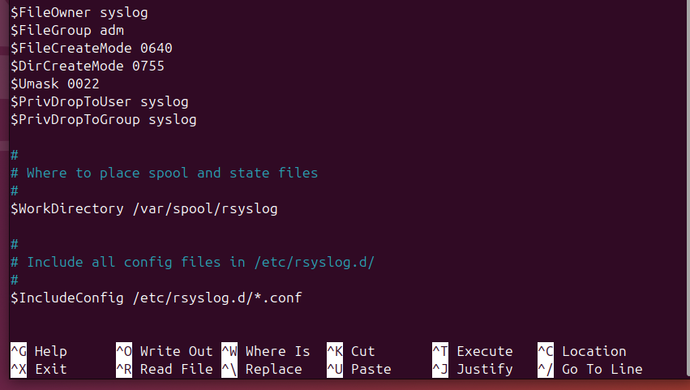

**Question: logrotate.conf setting (meaning by item)**

Answer:

* Format:

<log_file_path> {

option1

option2

…

}

* Option explained:
* daily: rotate log files every day
* weakly: rotate log file once a week
* monthly: rotate log files once a month
* rotate N: keep N archived log files; older ones will be deleted
* compress: compress old log files
* delaycompress: delay compression until the next rotation cycle
* missingok: do not show an error if the log file is missing
* notifempty: skip rotation is the log file is empty
* dateext: add date based suffix to rotated files
* sharedscript: ensures postrorate and prerotate scripts are run only once for all matched files in a block
* postrorate … endscript: commands to run after rotating logs, often used to restart services
* prerotate … endscript: commands to run before rotating logs
* include <dir>: include all configuration files from another directory

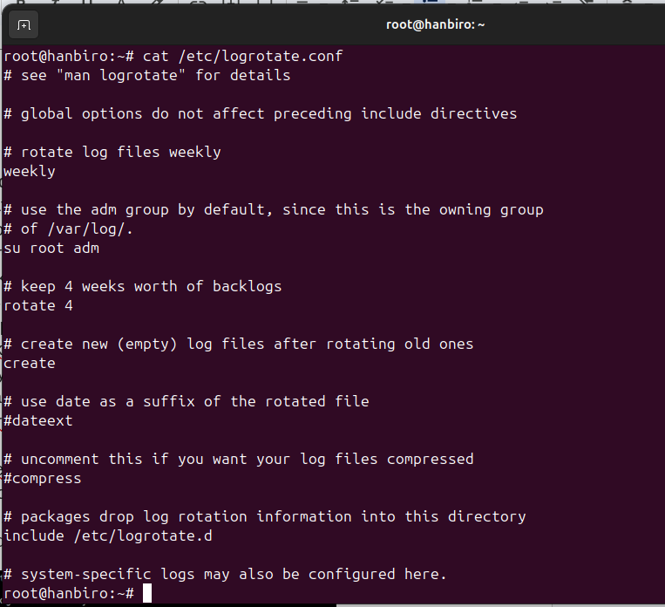

**6. Xinetd (Superdemon)**

**Question: What is a Xinetd Daemon?**

**Answer:**

* Xinetd (eXtended InterNET Daemon) is a super-server daemon used on Unix/linux system to manage network-based services
* It listens for incoming connection requests on predefined ports and, upon receiving a request, launches the appropriate service only when needed
* Xinetd also provides advanced features like access control, logging and connection limits

**Question: Set up and run ftp and rsync using Xinetd.**

**Answer:**

* Step 1: Install required packages:

sudo apt update

sudo apt install vsftpd rsync xinetd -y

* Step 2:
* disable vsftpd service running standalone to avoid port occupation when xinetd tries to run FTP

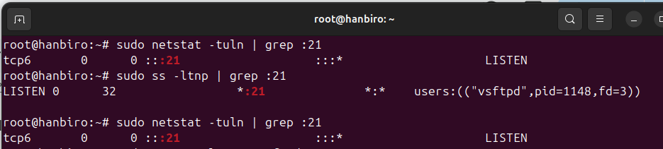

sudo systemctl stop vsftpd

sudo systemctl disable vsftpd

* create and config FTP service under Xinetd:

sudo nano /etc/xinetd.d/ftp

* add content:

*service ftp*

*{*

*disable = no*

*socket_type = stream*

*wait = no*

*user = root*

*server = /usr/sbin/vsftpd*

*log_on_success += HOST DURATION*

*log_on_failure += HOST*

*}*

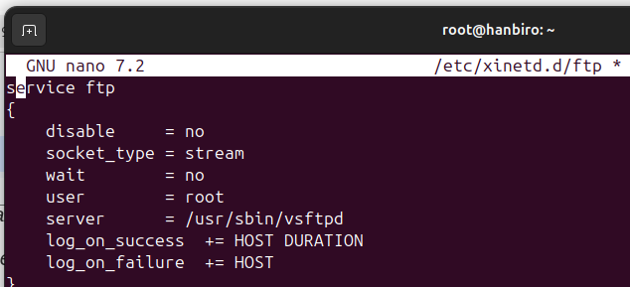

* Step 3:
* create Rsync Config in Xinetd: *sudo nano /etc/xinetd.d/rsync*
* add content:

*service rsync*

*service rsync*

*{*

*disable = no*

*socket_type = stream*

*wait = no*

*user = root*

*server = /usr/bin/rsync*

*server_args = --daemon*

*log_on_failure += USERID*

*}*

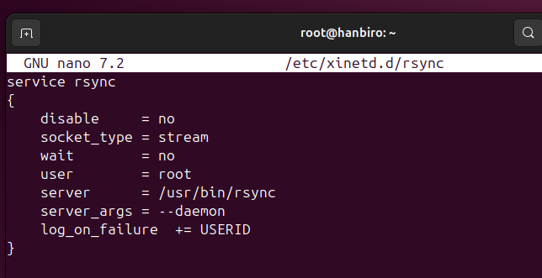

* Step 4: make sure the vsftpd and rsync services are not running independently

sudo systemctl stop vsftpd rsync

sudo systemctl disable vsftpd rsync

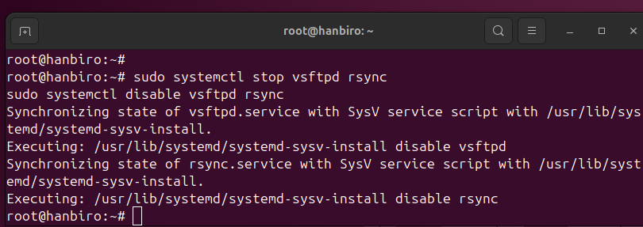

* Step 5: Restart Xinetd and Rsync services

sudo systemctl restart xinetd

sudo systemctl enable xinetd

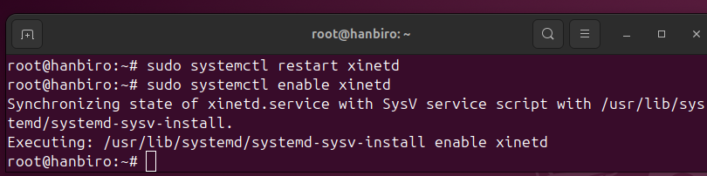

* Step 6:
* Check if Xinetd is running: sudo systemctl status xinetd

Expected: Active: active (running)

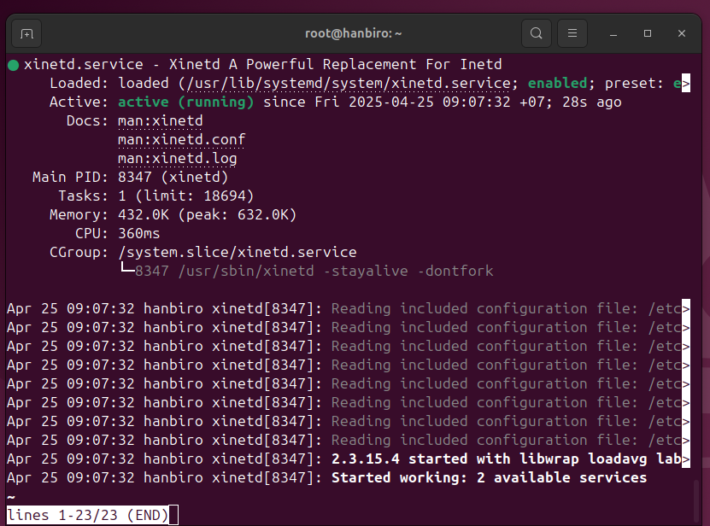

* check open ports (21|873):

sudo netstat -tuln | grep -E "21|873"

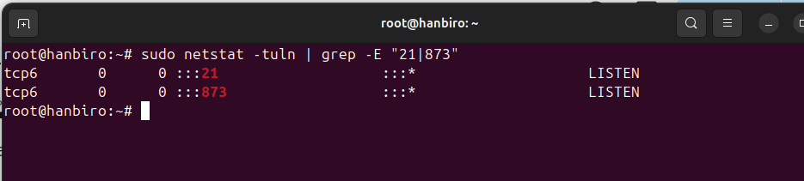

* check FTP

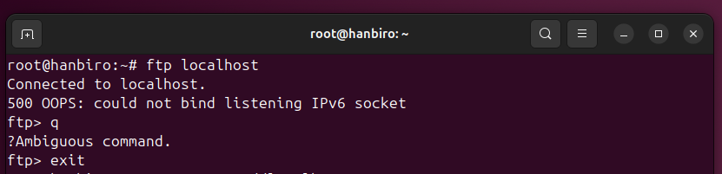

**issue:** vsftpd (under xinetd) cannot bind to IPv6 socket

**resolve:**

* edit file: sudo nano /etc/vsftpd.conf

listen=NO

listen_ipv6=NO

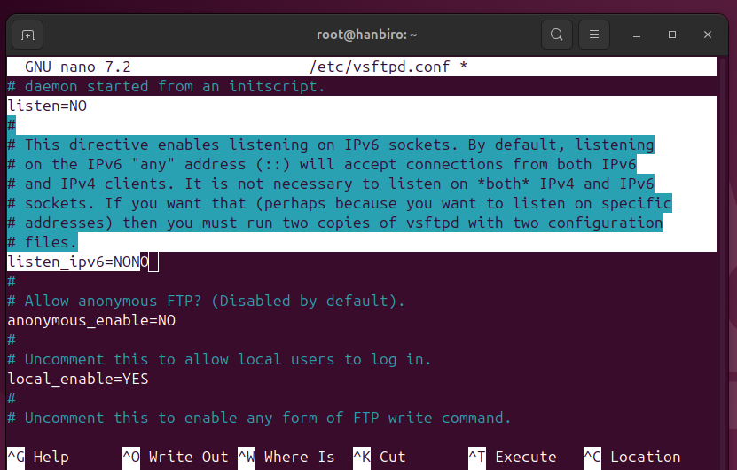

* restart service: sudo systemctl restart xinetd
* retry ftp:

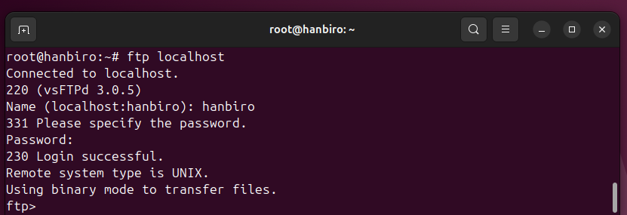

* check rsync via xinetd

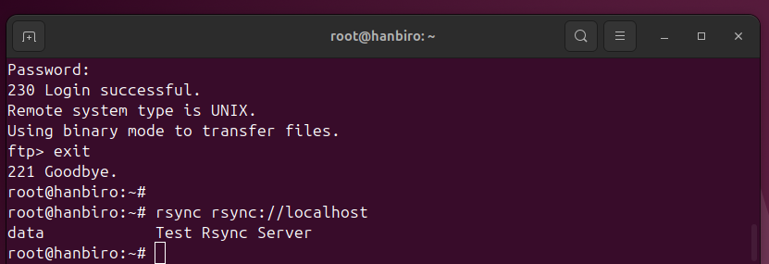

**7. Rsync Practice**

**Question: Meaning of rsyncd.conf**

**Answer:** rsync.conf is the configuration file file for rsync when running in daemon mode. It allows data sync over TCP port 873 without SSH

Main settings:

* modules: directories that can be synced
* permissions: controls access to the defined modules
* authentication: user authentication for accessing modules
* logging: transfer: logs information about transfers and any errors
* transfer setting: transfer behavior (compression, limits, …)

**Question: Data synchronization using rsync 873 port**

**Answer:**

**Explanation and for Exam:**

**Push rsync data (client->server)**

rsync -avz /local/dir/ rsync://remote-host/module/

* Note:

-a: Archive mode (preserves permissions, timestamps, symbolic links, …)

-v: Verbose output

-z: Compress data during the transfer

/local/directory/: Source directory on the local machine

rsync://remote-server/module/: Destination module defined in rsyncd.conf on the remote server

**Pull rsync data (server->client): retrieve data from rsync server to local machine**

rsync -avz rsync://remote-server/module/ /local/dir/

**[ TEST ] on only Ubuntu: synchronize with rsync over port 873 (daemon mode) by making client and server on the same machine**

**I use 2 servers:**

* **VM1: Master Server - 192.168.159.10 (CentOS9)**
* **VM2: Slave Server - 192.168.159.20 (CentOS9)**

***On VM1:***

* sudo dnf install rsync
* edit the rsyncd.conf file to specify the directories that the server will share

sudo nano /etc/rsyncd.conf

*config:

[files]

path = /home/kiet/files

comment = "Rsync File Sharing"

read only = no

list = yes

uid = nobody

gid = nobody

auth users = rsyncuser

secrets file = /etc/rsyncd.secrets

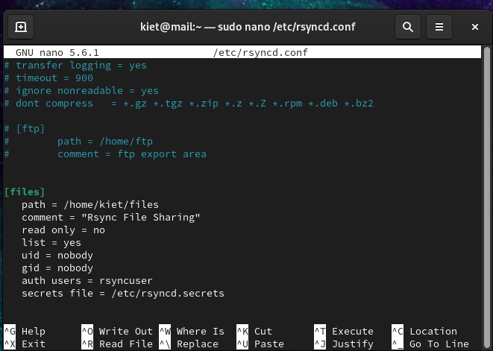

* create dir and authorize:

mkdir -p /home/kiet/files

sudo chmod 666 /home/kiet/files

* create a file containing user information and password for authentication when connecting to the rsync daemon

sudo nano /etc/rsyncd.secrets

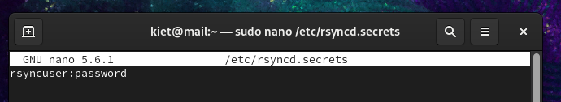

* edit permissions for this file for security

sudo chmod 600 /etc/rsyncd.secrets

* start service

sudo rsync --daemon

* check port:

sudo netstat -tulnp | grep 873

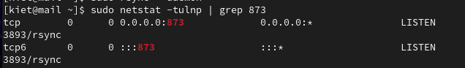

* add port to firewall

sudo firewall-cmd --permanent --add-port=873/tcp

sudo firewall-cmd --reload

***On VM2***

* sudo dnf install rsync
* create dir and authorize:

mkdir -p /home/kiet/source

sudo chmod 666 /home/kiet/source

* test VM1 connectivity from VM2 using telnet

telnet 192.168.159.10 873

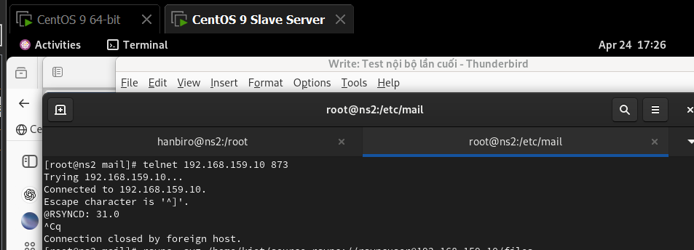

* **echo "This is a test file" > /home/kiet/source/testfile.txt**

**Push rsync data (VM2 client -> VM1 server)**

* run:

rsync -avz /home/kiet/source rsync://rsyncuser@192.168.159.10/files

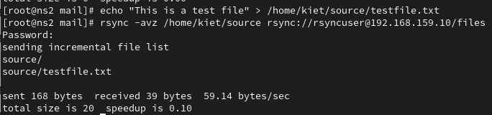

* **check VM1**

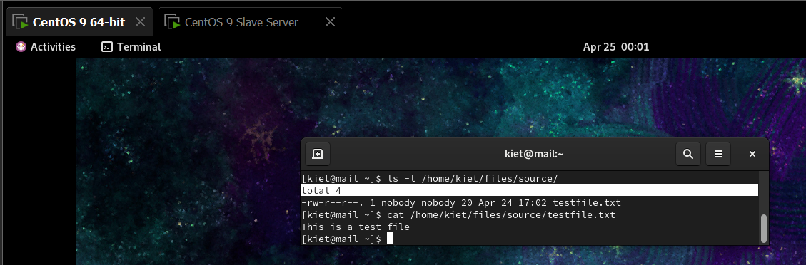

**Pull rsync data (VM1 server-> VM2 client)**

* run (on VM2):

rsync -avz rsync://rsyncuser@192.168.159.10/files /home/kiet/destination

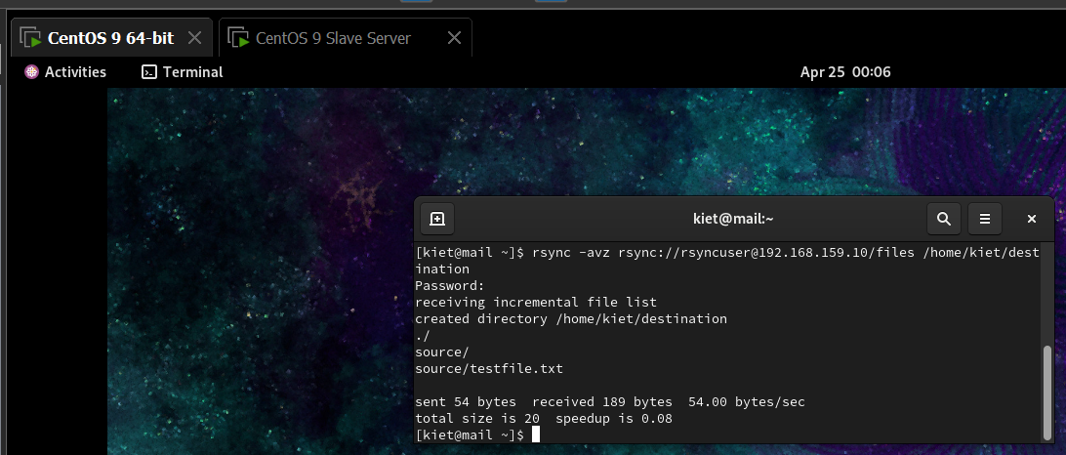

* **check VM2**

mkdir -p /home/kiet/destination

chmod 755 /home/kiet/destination

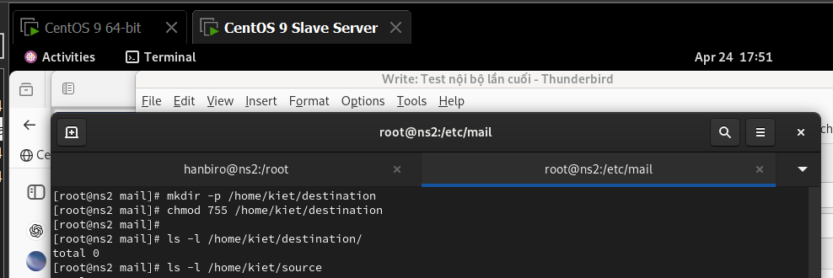

* pull from VM1 (~/files) and check (run at **VM2**)

rsync -avz rsync://rsuncuser@192.168.159.10/files /home/kiet/destination

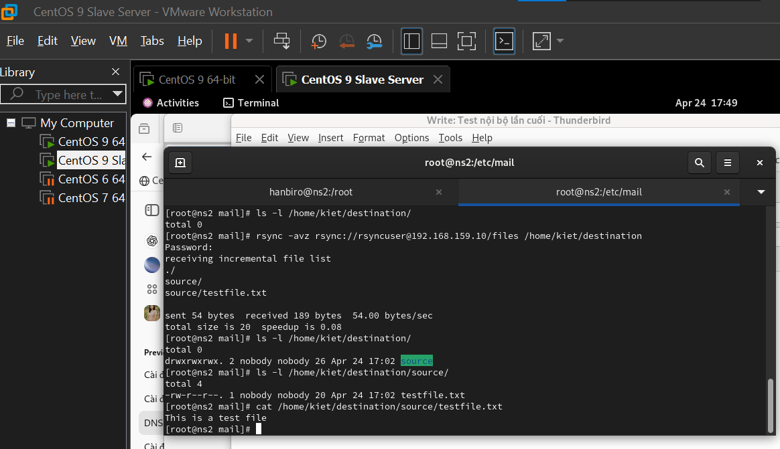

**Question: Data synchronization using rsync ssh protocol: safer than rsync daemon on port 873**

**Answer:**

**Push rsync data (local->remote): sends local data to a remote server securely via SSH**

rsync -avz -e ssh /local/dir/ user@remote:/remote/dir/

* note**:**

-e ssh: Use SSH for secure connection

**Pull rsync data (remote->local): retrieves remote data securely to the local machine**

rsync -avz -e ssh user@remote:/remote/dir/ /local/dir/

**Data synchronization with rsync ssh password auto authentication**

* ***Option 1: use SSH Keys - no need to enter password after setting up the SSH Key***

ssh-keygen -t rsa

ssh-copy-id user@remote

rsync -avz -e ssh /local/dir/ user@remote:/remote/dir/

* ***Option 2: Use sshpass - automates password input but is less secure***

sudo apt install sshpass

sshpass -p 'enter_password' rsync -avz -e ssh /local/dir/ user@remote:/remote/dir/

**[ practice ] on only Ubuntu: synchronize with rsync over port 873 (daemon mode) by making client and server on the same machine**

**I use 2 servers:**

* **VM1: Master Server - 192.168.159.10 (CentOS9)**
  + **VM2: Slave Server - 192.168.159.20 (CentOS9)**
* on VM1 and VM2:

sudo dnf install openssh-server

sudo systemctl enable sshd

sudo systemctl start sshd

sudo systemctl status sshd

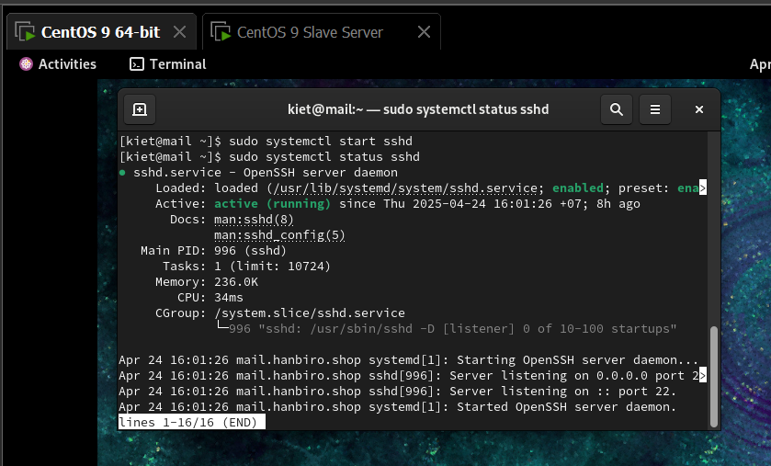

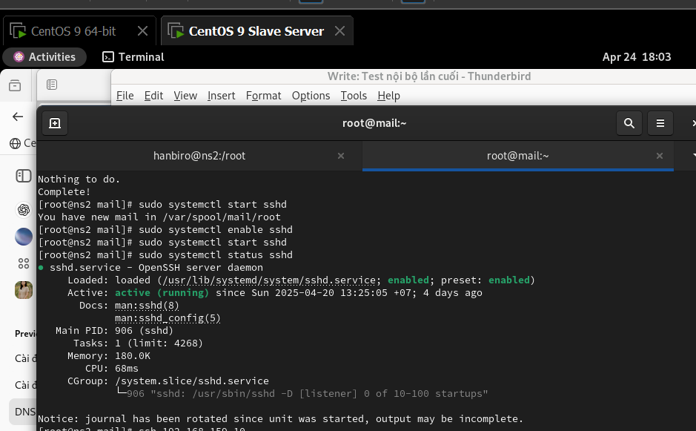

* on **VM2**, test connectivity to VM1 via SSH:

ssh 192.168.159.10

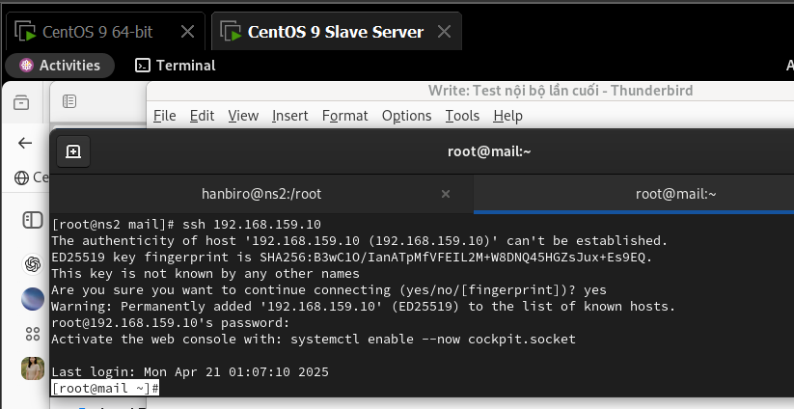

* on **VM2**, create SSH key pair

ssh-keygen -t rsa -b 2048

* copy SSH Public Key from **VM2** to **VM1** so no need to enter password

ssh-copy-id rsyncuser@192.168.159.10

**Login without password is successful**

**ssh rsyncuser@192.168.159.10**

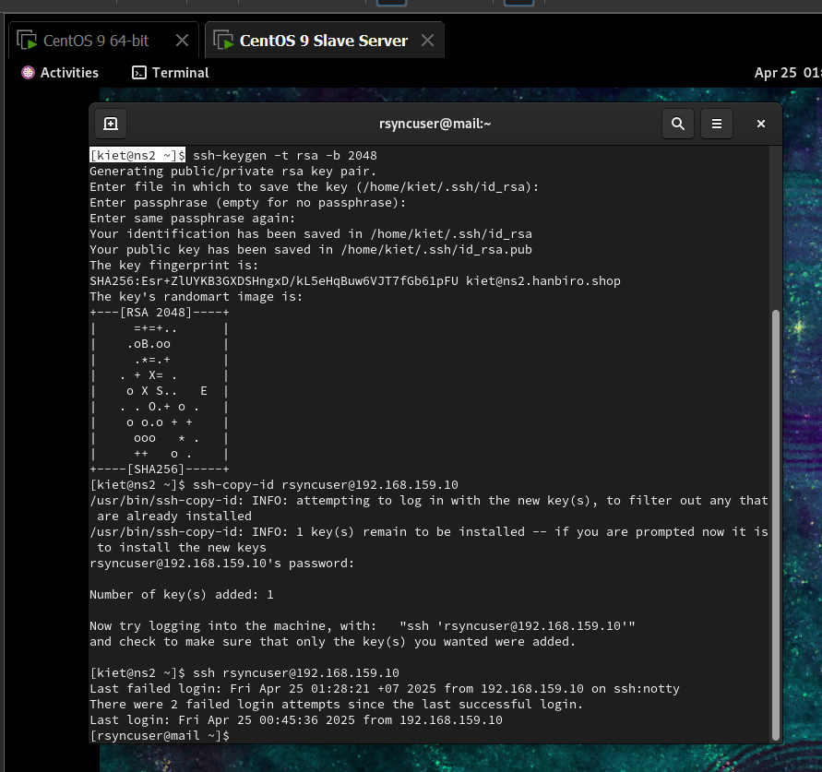

* back to VM2, create test_push.txt and push rsync data (client -> server)

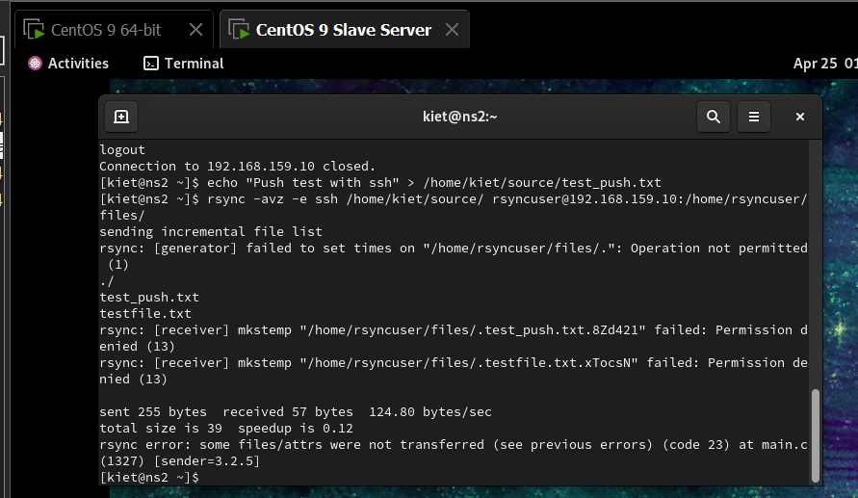

* on **VM1:** create and chown for user **rysncuser** and **/home/kiet/files**

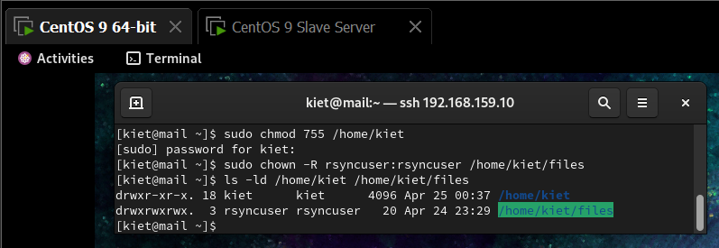

* pre check **VM1**

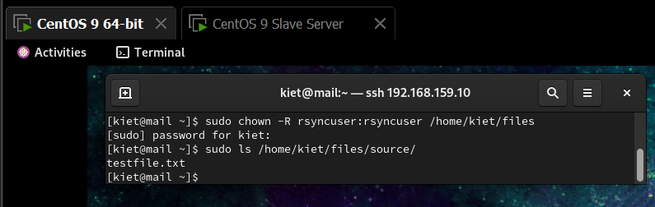

* pre check **VM2**

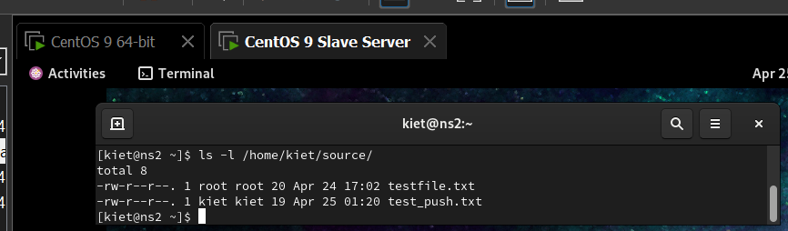

**Push rsync data (VM2 client -> VM1 server)**

rsync -avz -e ssh /home/kiet/source/ rsyncuser@192.168.159.10:/home/kiet/files/

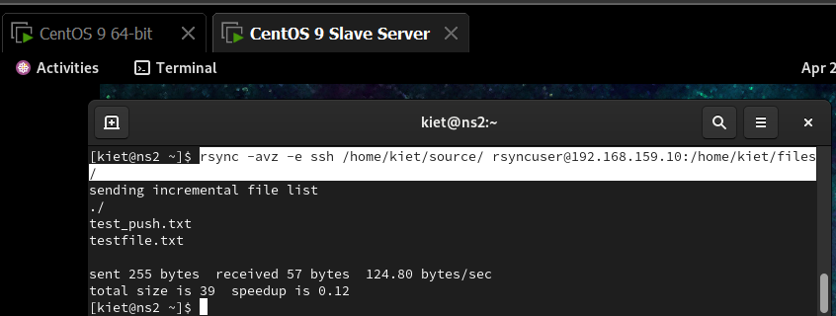

* check **VM1** from **SSH (VM2):**

ssh rsyncuser@192.168.159.10

ls /home/kiet/

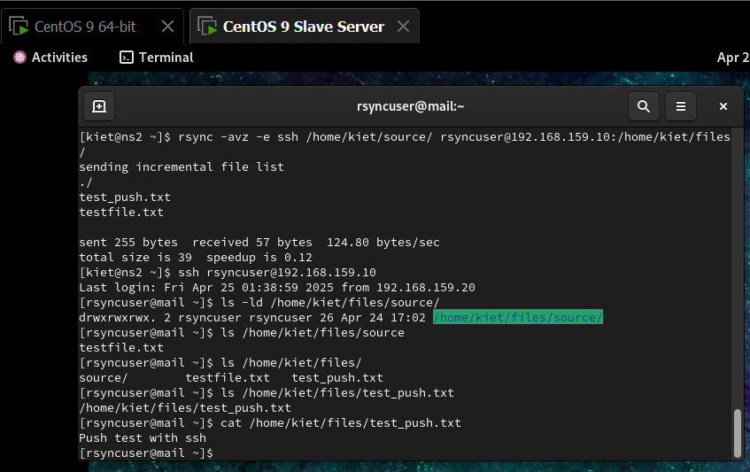

**Push rsync data (VM2 client -> VM1 server)**

* exit ssh
* pull /home/kiet/files from VM1

rsync -avz -e ssh rsyncuser@192.168.159.10:/home/kiet/files/ /home/kiet/destination/

* check on **VM2**

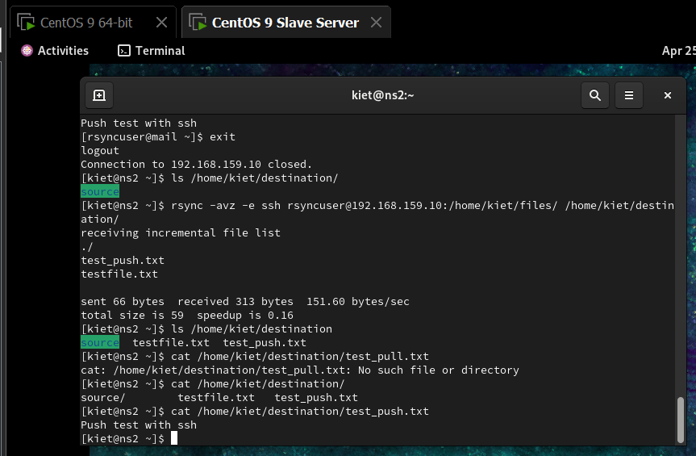

**8. tar Compression, decompression, devided compression, Check the list**

**create test directory and sample files**

mkdir -p ~/tar_demo/test_folder

echo "File 1 - Hello Tar!" > ~/tar_demo/test_folder/file1.txt

echo "File 2 - More Content" > ~/tar_demo/test_folder/file2.txt

cd ~/tar_demo

**Question: Way of tar compression**

**Answer:** Tar (tape archive) is a powerful tool on Linux/Unix used to compress and archive files or directories into a single file. Create TAR archive files:

tar -cvf archive.tar /path/to/files

tar -czvf archive.tar.gz /path/to/files # compress with gzip

tar -cjvf archive.tar.bz2 /path/to/files # compress with bzip2

* -c: create archive
* -v: verbose (show file)
* -f: specify archive file
* -z: compress with gzip
* -j: compress with bzip2

ex:  
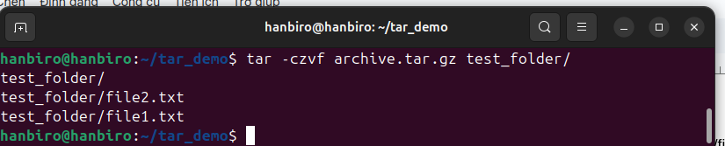

**Question: Way of decompression the tar**

**Answer:**

tar -xvf archive.tar

tar -xzvf archive.tar.gz

tar -xjvf archive.tar.bz2

note: -x to extract

ex:

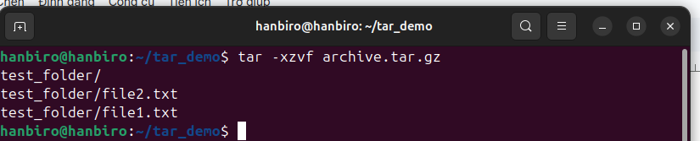

**Question: Way of tar devided compression**

**Answer:**

tar -czf - /path/to/files | split -b 1M - archive.tar.gz.part_

* note:
* -: pipe output to split
* -b 1M: split into 1MB to chunks
* archive.tar.gz.part_: prefix for split file

ex:

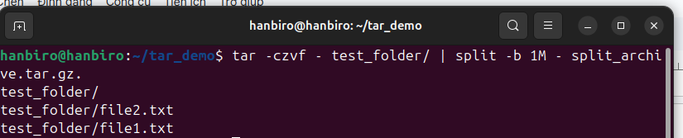

**Question: Check list in the single compressed file of tar**

**Answer:**

tar -tvf archive.tar

tar -tzvf archive.tar.gz

tar -tjvf archive.tar.bz2

ex:

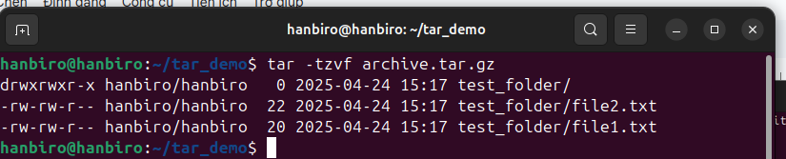

**9. awk, xargs, ps, pstree, sed**

**pre test:**

echo -e "name:age:job\nAlice:30:Engineer\nBob:25:Designer\nCharlie:35:Artist" > file.txt

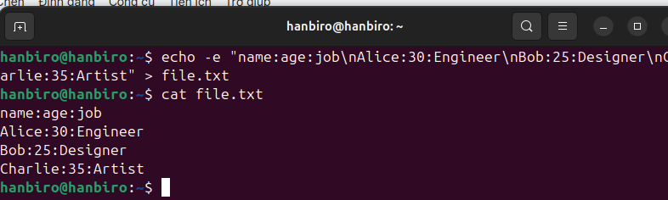

**Question: How to use awk**

**Answer:**

‘awk’ is a powerful text-processing tool that work line by line, splitting field and allowing pattern-based action

syntax:

*awk ‘/search-pattern/ { action1; another-action; }’file-to-parse*

note:

* /search-pattern/ : sample search for content
* action1; another-action; : what to do when the pattern is matched
* file-to-parse: file name or path

Ex:

* print columns:

awk -F ':' '{print $1, $3}' file.txt

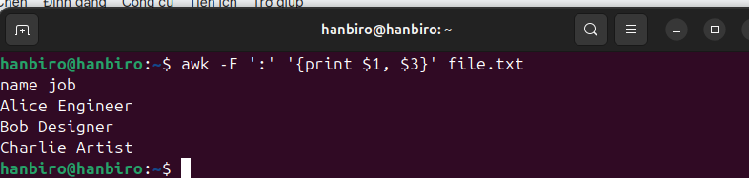

* use condition to filter rows where column 2 is greater than 30 (age):

awk -F ':' '$2 > 30 {print $1, $2}' file.txt

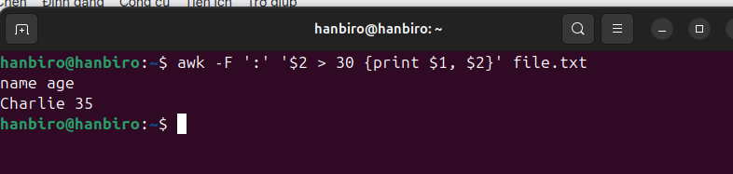

* calculate the total age (column 2) of all people:

awk -F ':' '{sum += $2} END {print sum}' file.txt

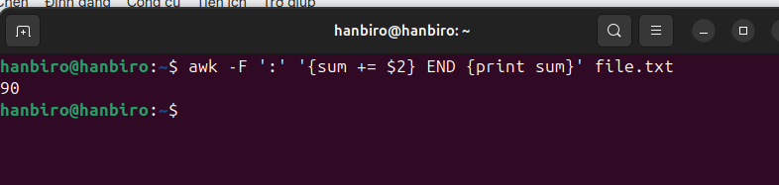

**Question: How to use xargs+ ps**

**Answer:** xargs is used to pass multiple values (like PIDs) as arguments to other commands — such as ps. It's useful when you extract a list (like from awk) and want to act on all items

Ex: check details of all processes related to nginx service

ps -ef | grep bash | grep -v grep | awk '{print $2}' | xargs -r ps -fp

ps -ef: list all processes

grep bash: find lines containing “bash”

grep -v grep: exclude the ‘grep’ command itself

awk '{print $2}': extract the 2nd column (PID)

xargs -r ps -fp: pass those PIDs to ps -f to show full info

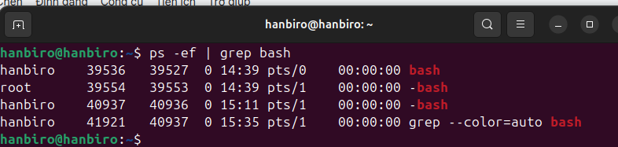

***# ps***

**Question: How to use ps**

**Answer:**

syntax: ps [options]

*with options:

* -e: show all processes

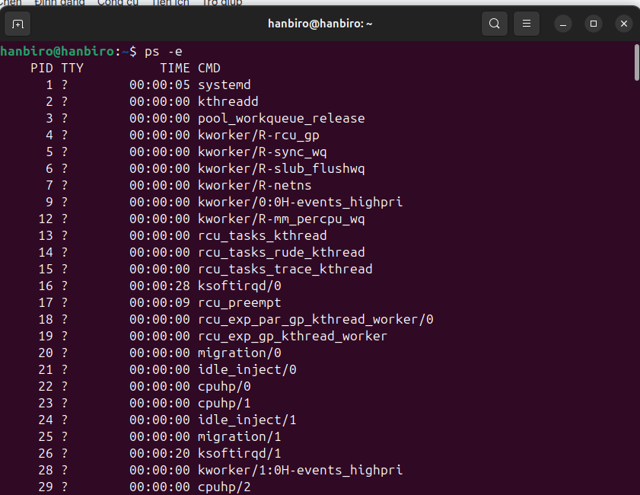

* -f: show full format listing

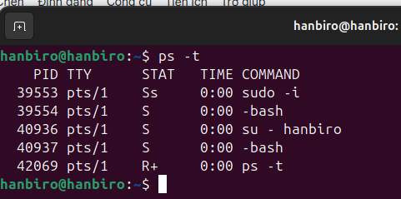

* -l: displays long format listing

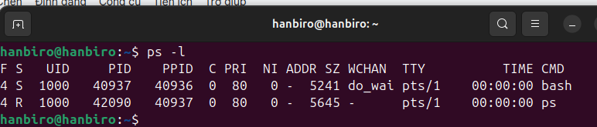

* -j: displays jobs format

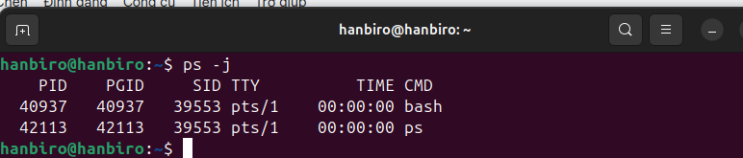

* -u <user>: show processes for a specific user

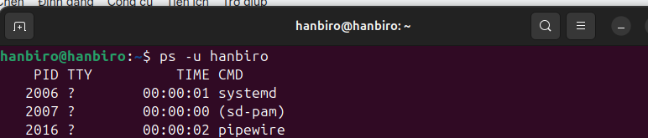

-

* p <PID>: show processes with specific PID

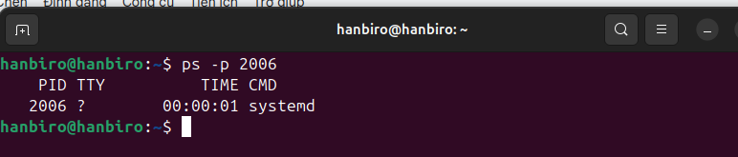

* -t: <TTY>: show processes associated with a specific terminal

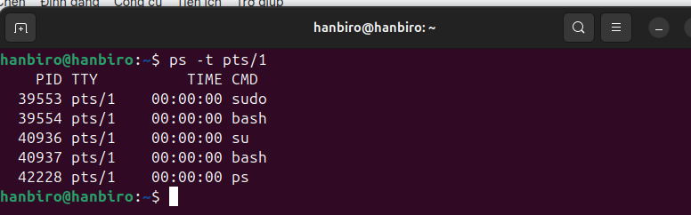

**Question: What is the status by the Ps (Z,T,S,R,etc) stat code?**

**Answer:**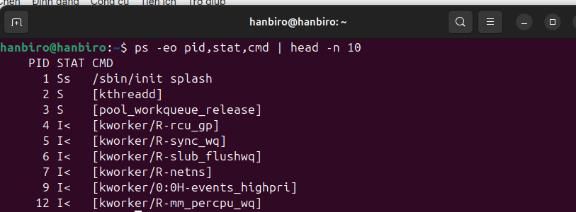

D Waiting for I/O (can’t be interrupted)

R Running or ready to run

S Sleeping, can be interrupted

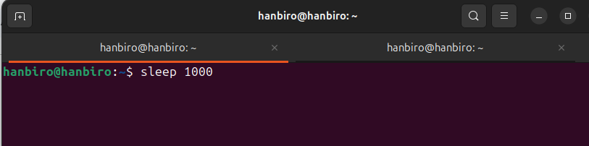

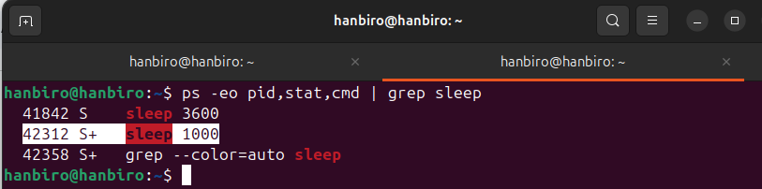

T Stopped (paused by signal/debugger)

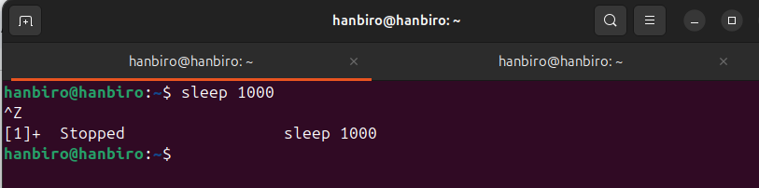

X Dead process

Z Zombie – finished but not cleaned up

! nano zombie.c:

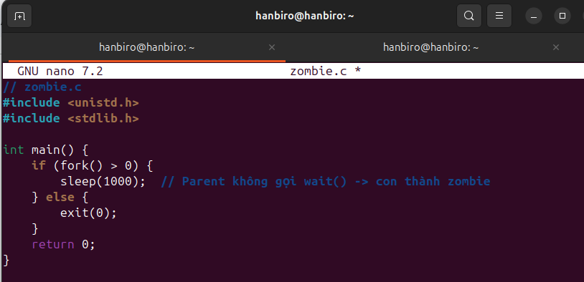

! combile and run

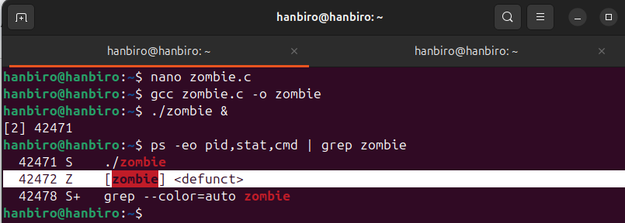

**Question: How to use the pstree**

**Answer:** pstree shows running processes in a tree structure, displaying parent-child relationships

* pstree: shows processes in a tree format

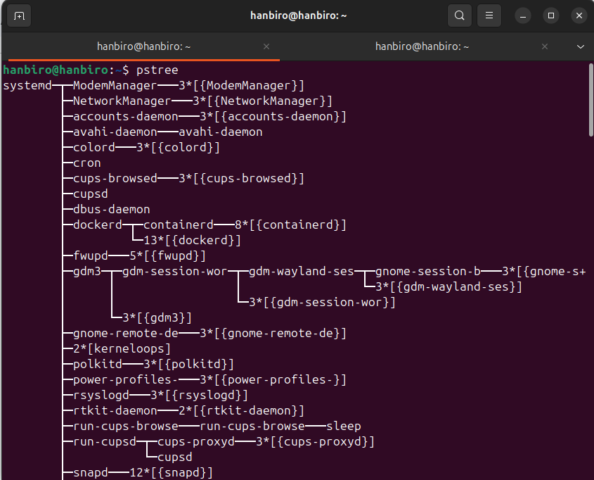

* pstree -p: show PIDs along with process names

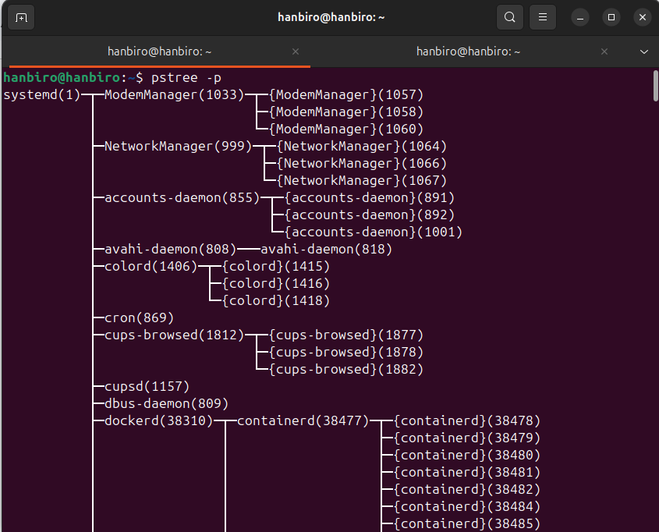

* pstree -u: show the user running each process

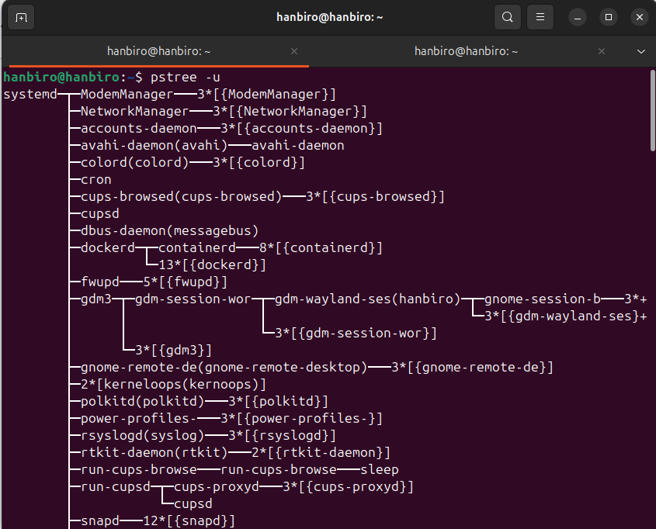

* pstree <pid>: show the subtree starting from a specific process ID

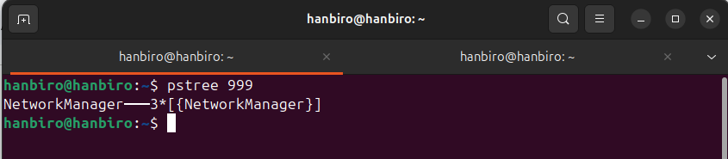

**Question: Transforming specific file values using a sed**

**Answer:** sed (stream editor) is used to search, replace, or modify text in a file

sed 's/search_pattern/replacement/' filename

* Replace specific words or values
* Edit only specific lines or patterns
* Save changes directly to the file (-i option)
* Work efficiently in scripts or pipelines

**pre test:**

echo -e "apple\nbanana\nfoo\napple\nfoo" > file.txt

Ex:

sed 's/foo/bar/' file.txt # replace first "foo" with "bar"

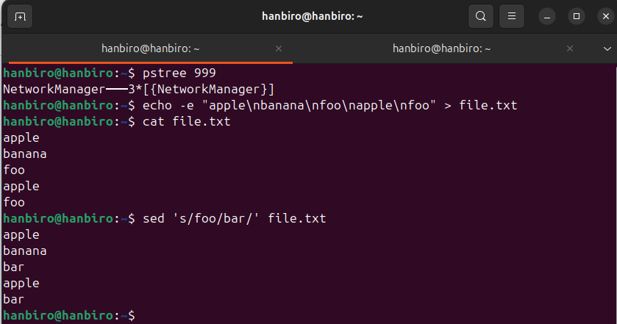

sed 's/foo/bar/g' file.txt # replace all "foo" with "bar"



sed '/error/d' file.txt # delete lines containing "error"



sed -n '5,10p' file.txt # print only lines 5 to 10

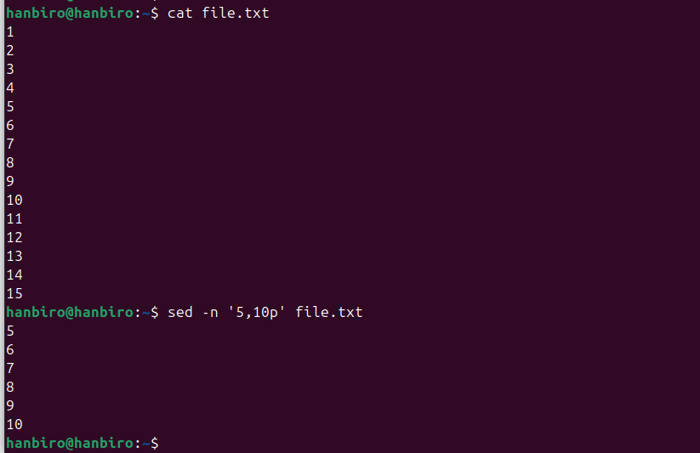

sed -i 's/old/new/g' file.txt # replace and save in place

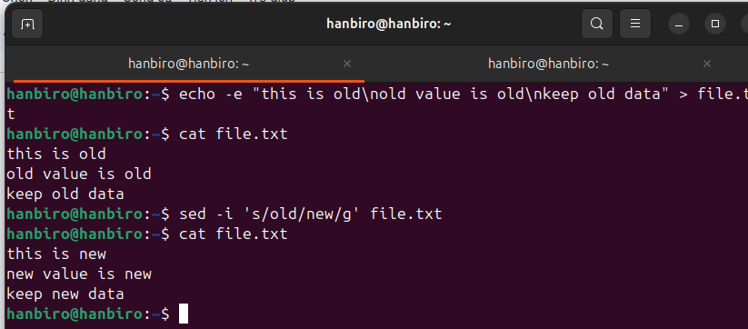

**10. System Monitoring**

**Question: How to use top**

**Answer:** ‘top’ shows real-time information about system performance, including CPU, memory, and process usage

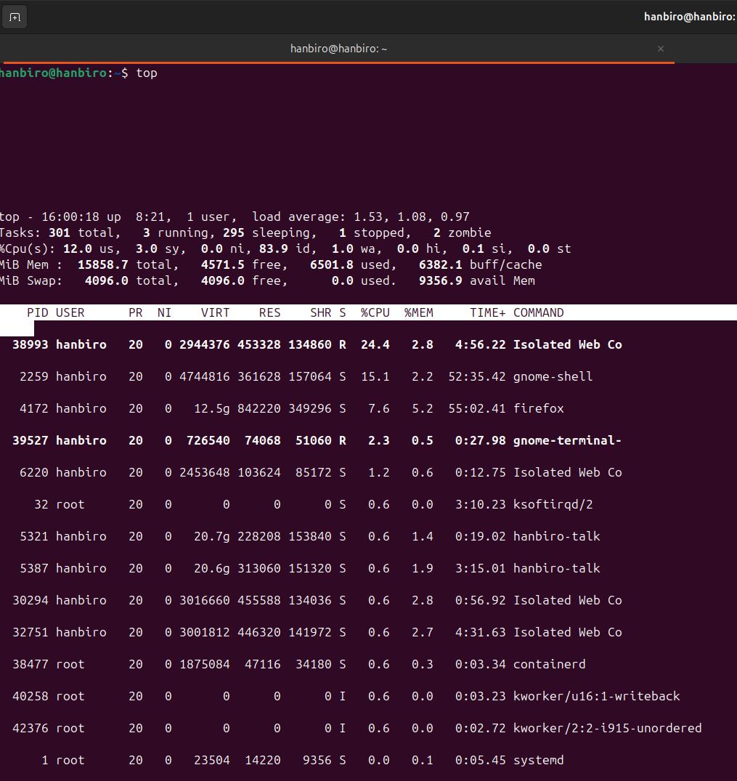

Important keys:

* P: sort by CPU usage

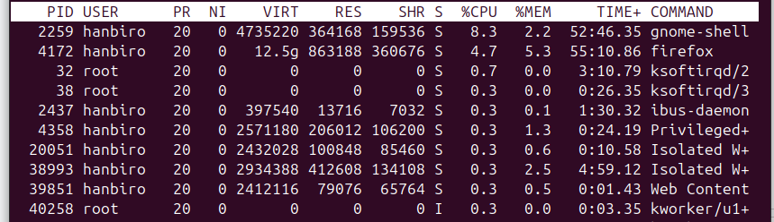

* M: sort by memory usage

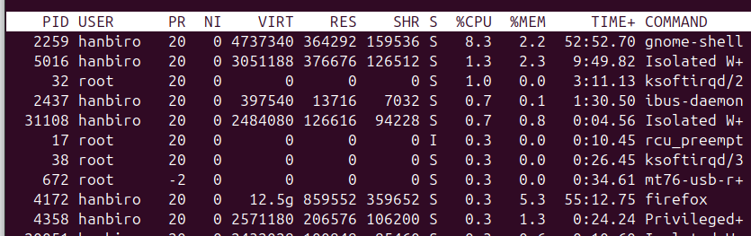

* T: sort by runtime

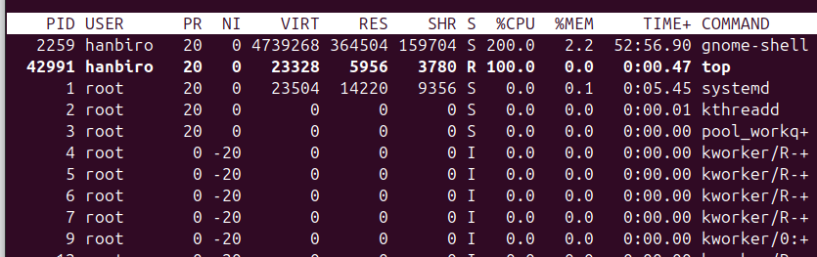

* k: kill a process

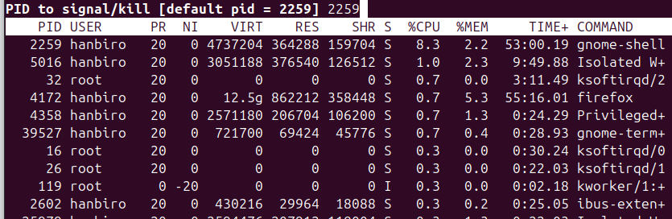

* r: Renice (change priority)

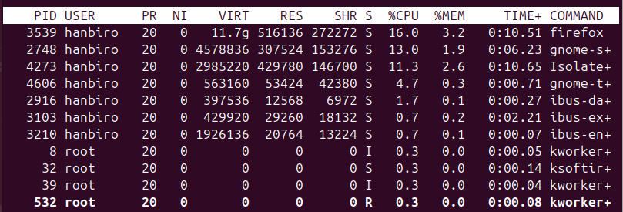

* q: quit

**Question: How to use the sar**

**Answer:** sar (system activity reported) collect, report and save system performance metrics

syntax: sar [options] [interval] [count]

ex:

sudo apt update

sudo apt install sysstat

enable automatic data collection (optional to view historical logs):

sudo nano /etc/default/sysstat

*edit: ENABLED="false" -> true

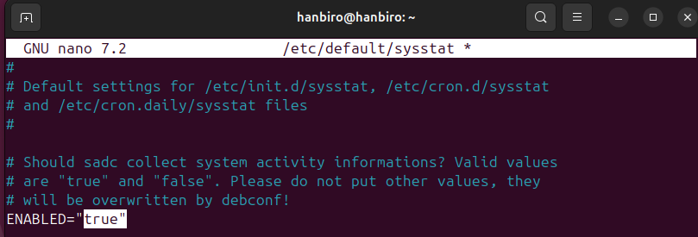

* enable and restart service:

sudo systemctl enable sysstat

sudo systemctl start sysstat

* show CPU usage every 1s, 5 times: *sar -u 1 5*

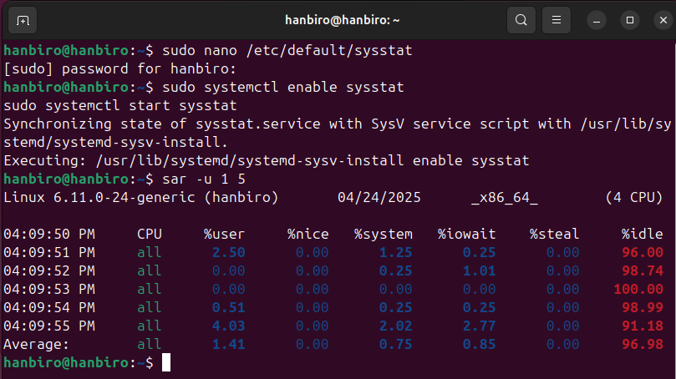

* show memory usage: *sar -r 1 3*

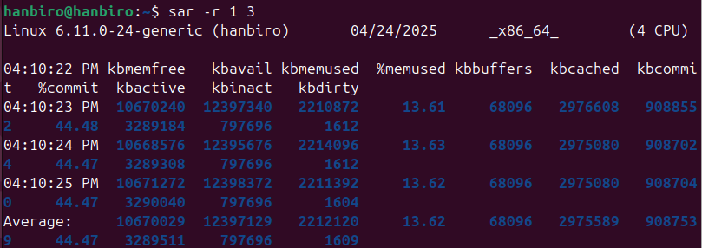

* show network interface usage: *sar -n DEV 1 3*

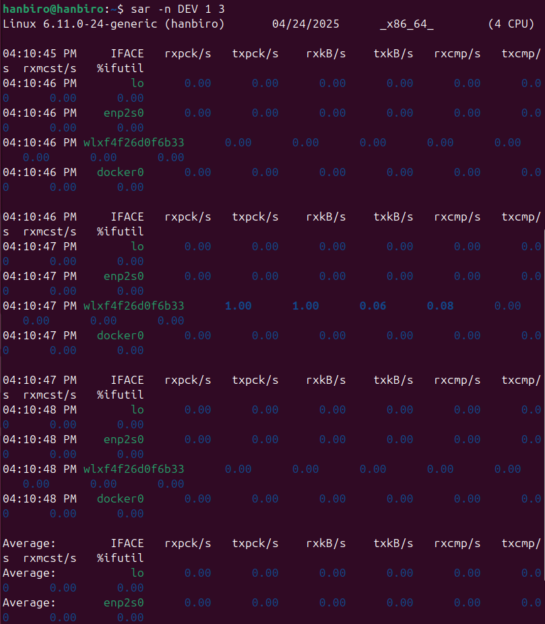

* show disk I/O: *sar -d 1 3*

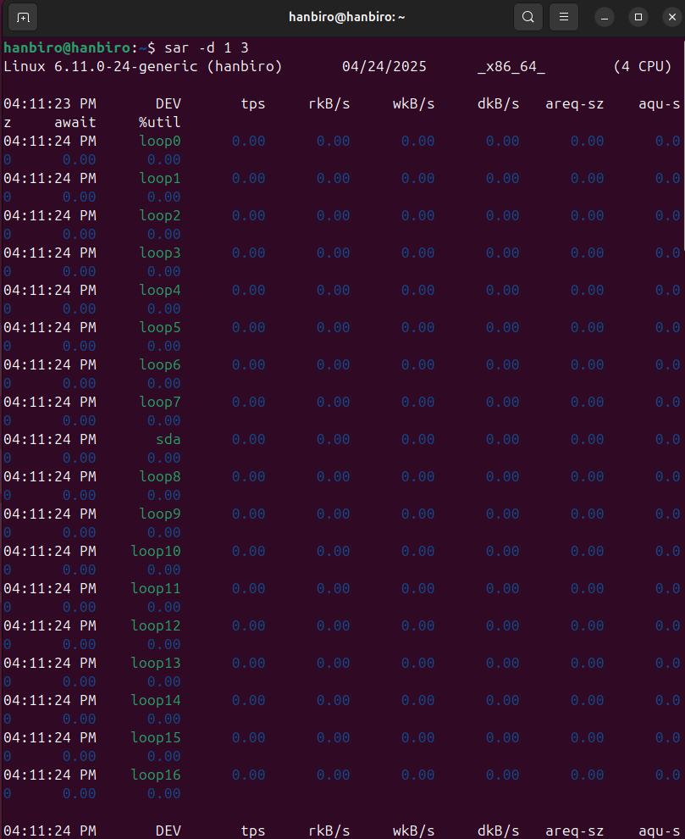

* show load average and run queue: *sar -q*

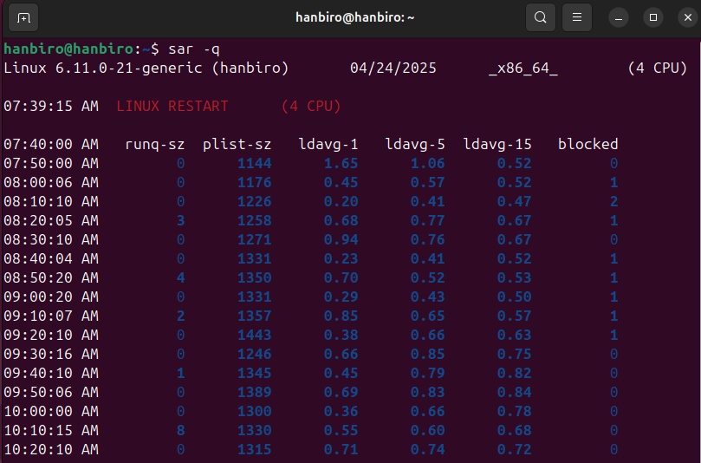

* historical log, data in /var/log/sa/: *sar -u -f /var/log/sysstat/sa\*\**

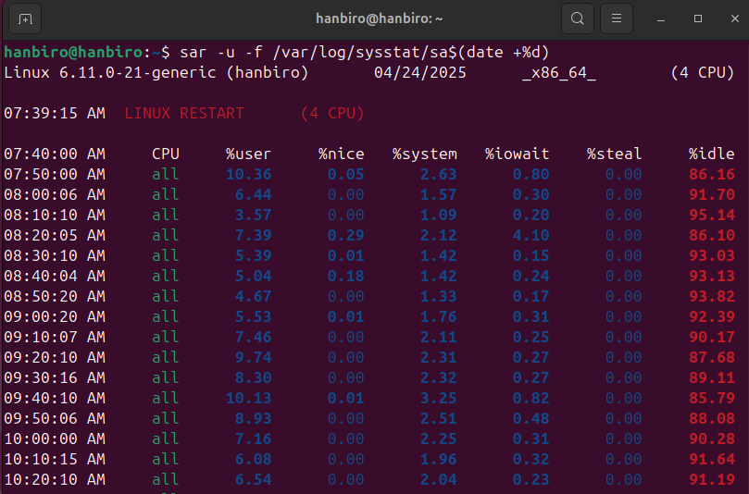

**Question: How to use iostat**

**Answer:** iostat (Input/Output Statistics) shows CPU usage and disk I/O performance

syntax: iostat [options] [interval] [count]

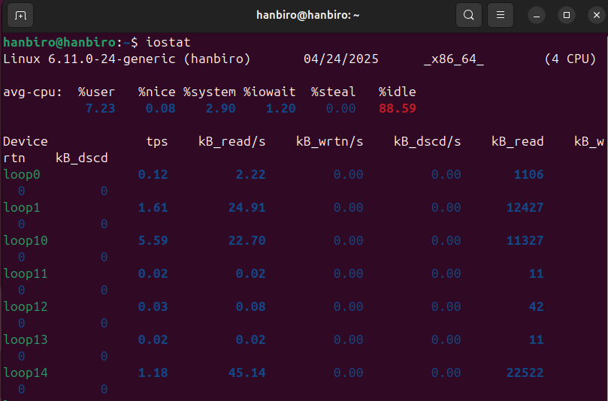

options:

* -c: show only CPU statistic

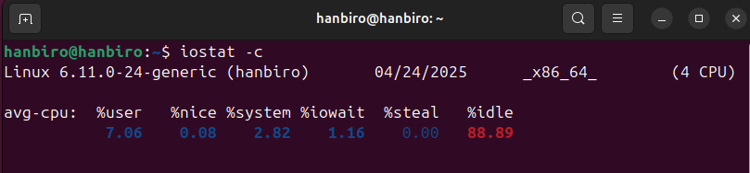

* -x: show extended I/O statistics

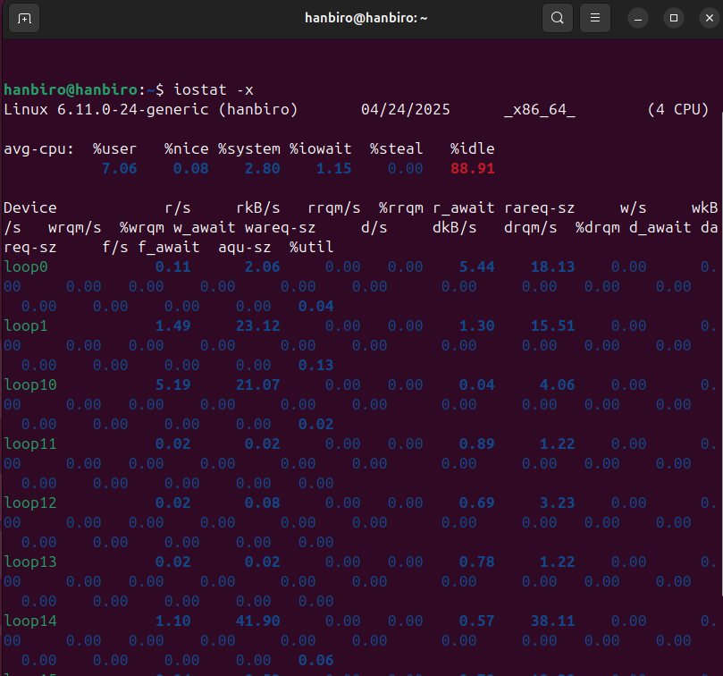

* -d: show only device I/O statistics

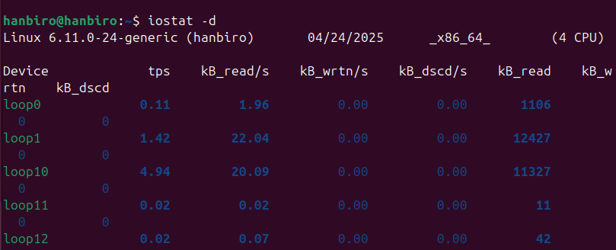

* -xd: extended I/O stats for devices only

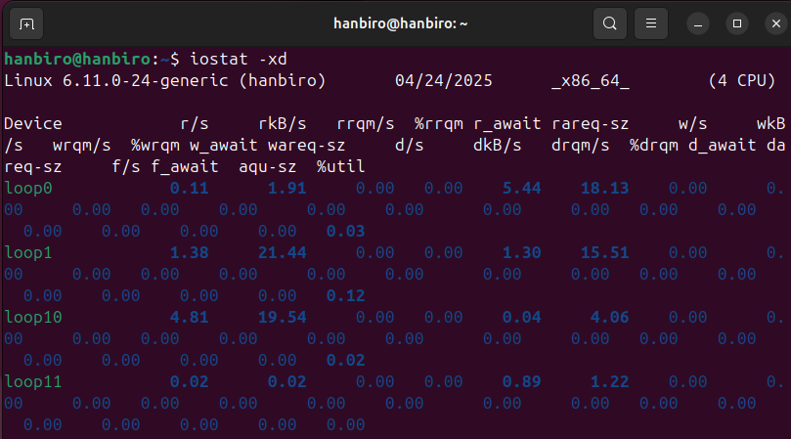

* -k / -m: show in KB/MB

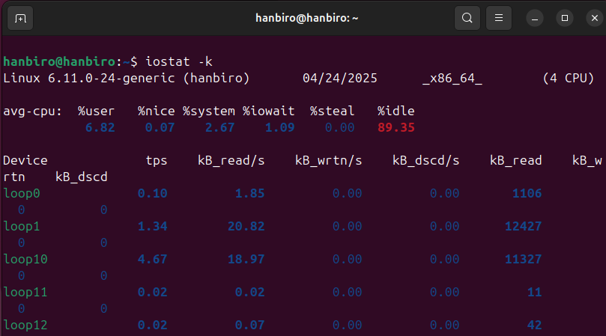

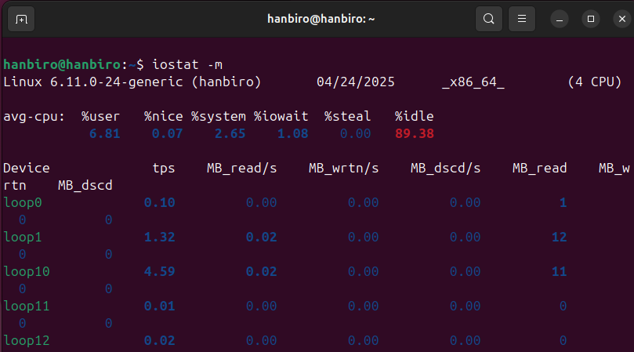

* -p: include partition stats

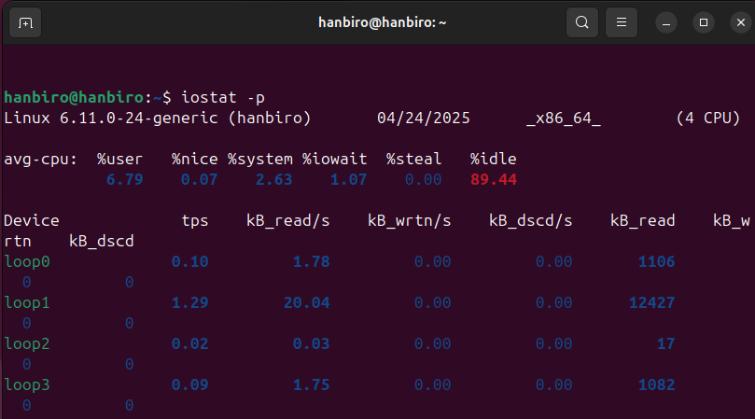

ex:

* extended stats every 1s, 3 times: *iostat -x 1 3KB*

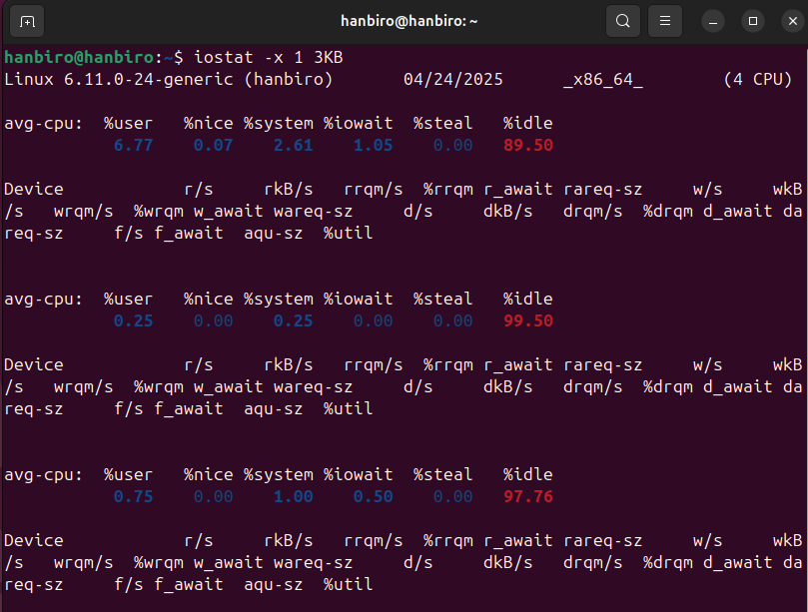

* update every 2s, 3 times, show stats in KB: *iostat –k 2 3*

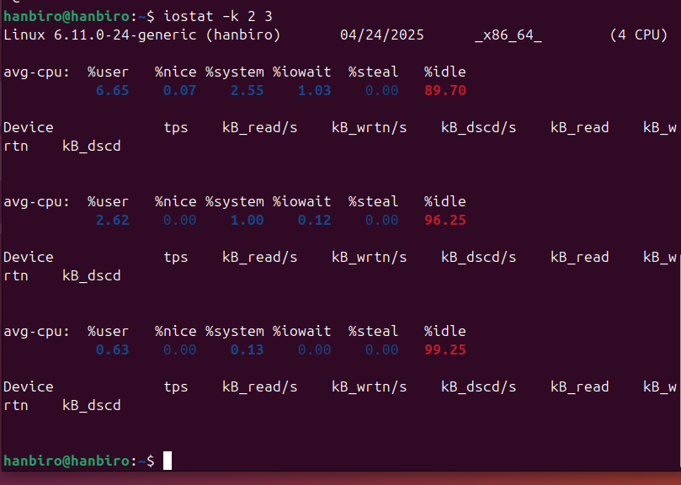

**Uptime:** shows how long the system has been running, how many users are logged in and the load average

syntax: uptime

16:16:22 up 11 min, 1 user, load average: 0.59, 0.62, 0.37

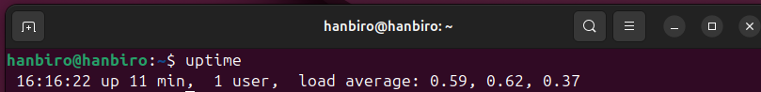

* 16:16:22: current time
* up 11 min, 7:42: system uptime
* 1 users: logged in users
* load average: 0.59, 0.62, 0.37: 1, 5, and 15 minutes load average

**Question: What is load average?**

**Answer:** load average is the average number of processes in the **run queue** or waiting for CPU over time (1, 5, 15 minutes)

ex: load average: 1.54, 1.96, 2.10: average system load over 1, 5, and 15 minutes

note:

* On a 4-core CPU, load < 4 is fine
* Load > core count means possible CPU congestion

**Question: Meaning by item that appears during uptime+ Differentiate CPU usage**

**Answer:** The load average indicates the number of processes waiting for CPU or I/O resources at any given time.

* Low values (e.g., 0.5-1.0 on a single-core CPU) → The system is running smoothly and not overloaded
* Equal to the number of CPU cores → The system is fully utilizing all available CPU cores
* Higher than the number of CPU cores → The system is under heavy load and may be overloaded

ex:

* Load average: 1.5 on a 4-core CPU → The system is running normally, with a moderate load
* Load average: 5.0 on a 2-core CPU → The system is overloaded, as the load exceeds the number of available CPU cores

**Question: What does it mean by user, nice, system, iowait, steal, idle?**

**Answer:** Each of these terms represents a percentage of CPU time dedicated to different tasks:

* user (%usr): CPU time for user-level app
* nice (%nice): CPU time for nice-priority processes
* system (%sys): CPU time for kernel/system process
* iowait (%iowait): waiting for I/O (disk/network)
* steal (%steal): time stolen by hypervisor
* idle (%idle): CPU not doing any work

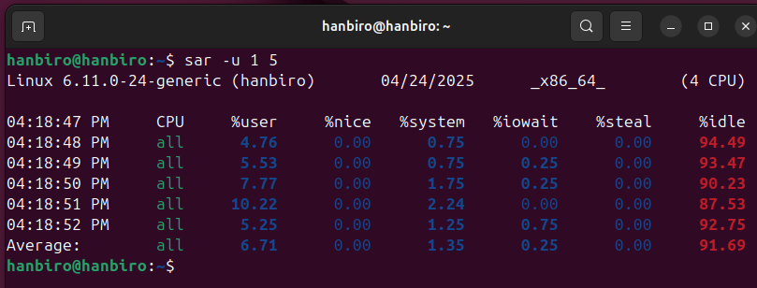

**Question: Classification memory usage**

**Answer:** Using the free -m command will show you memory stats

syntax: free -m

ex:

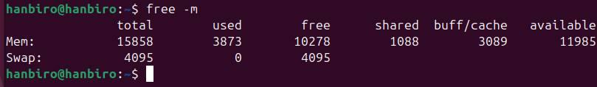

**Question: What does it mean of total, used, free , shared, buffers, cached, swap?**

**Answer:**

* total total physical memory
* used memory in use (excluding cache/buffer)
* free memory not in use at all
* shared memory used for shared libraries
* buffers memory used by kernel buffers
* cached memory used for file cache
* buff/cache combined buffer + cached
* available estimation of available memory without swapping
* swap disk space used as virtual memory

